Cloud Computing

**What is Cloud ?**

The cloud is A global network of servers that store and manage data, run applications, and deliver content and services over the internet. It allows users to access their files and data from any internet-capable device, whenever and wherever they want.

Cloud computing is possible because of virtualization, which creates a simulated, digital-only computer that behaves as if it were a physical computer.

**Why do we need a cloud ?**

Cloud computing can be beneficial for businesses and individuals because it provides on-demand access to computing resources and data storage without the need to manage physical devices or IT infrastructure. Some benefits of cloud computing include:

* **Scalability**

Businesses can scale up or down their storage and resources to meet their needs.

* **Disaster recovery**

Data can be mirrored across multiple redundant sites, making it easier and less expensive to recover from data loss.

* **Flexibility**

Businesses can focus on their core business goals instead of spending time on IT issues.

* **Security**

Distributed cloud technology can help protect user data by enabling data processing to occur closer to its origin.

* **Accessibility**

Data can be accessed from any internet-connected device.

* **Cost savings**

Cloud computing can help reduce costs by moving expenses from capital expenditure to operational.

* **Application development**

Developers can quickly deploy new applications or retire them without managing infrastructure.

**Disadvantages of Cloud**

Cloud computing has several disadvantages, including:

* **Internet connection dependency**: A poor internet connection can prevent access to cloud services. Cloud service providers may also experience downtime due to technical issues or natural disasters.
* **Security risks**: Cloud computing can be vulnerable to security risks such as data privacy, data loss, and online threats.
* **Vendor lock-in**: It can be difficult to move data from one cloud provider to another.
* **Loss of control**: Companies give up some control over their IT infrastructure when they move to the cloud.
* **Network dependency**: Networks can go down, which can prevent organizations from working.
* **Shared resources**: Shared resources can lead to performance degradation.
* **Integration complexity**: Integrating cloud computing with existing systems can be complex.
* **Unforeseen costs**: Cloud computing can lead to unexpected expenses.

**Difference Between Iass, Pass and Saas**

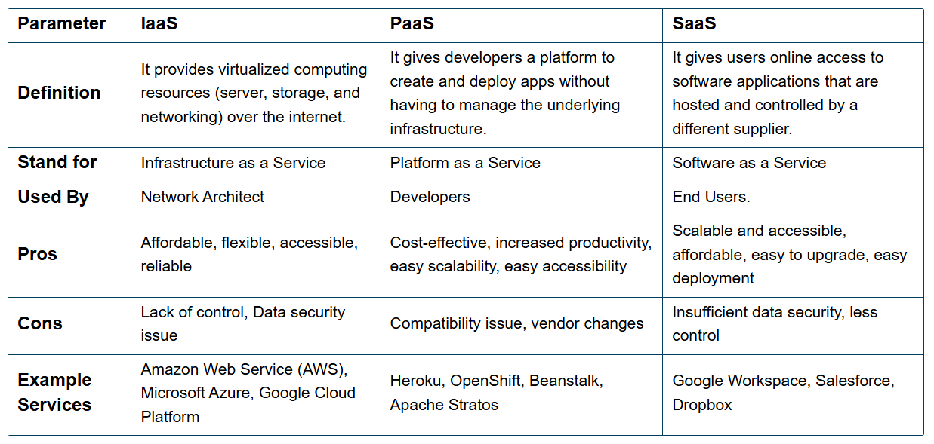

**Amazon web services**

Amazon Web Services (AWS) is a cloud computing platform that offers a range of services to help organizations and individuals become more agile, lower costs, and innovate faster:

**Services**

* AWS offers over 200 services, including compute, storage, database, networking, analytics, machine learning, and security

**Benefits**

* AWS allows businesses to replace upfront capital infrastructure expenses with low variable costs that scale with their business

**Customers**

* Millions of customers use AWS, including startups, enterprises, and government agencies

**Launch**

* AWS launched in 2006

**What is WebLogic Server ?**

Oracle WebLogic Server is a platform for developing, deploying, and running enterprise applications. It's a Java EE and Jakarta EE application server that can be used to run Java applications in the cloud or on-premises. Some of its features include:

**Scalability**: WebLogic Server offers a scalable implementation of Java EE and Jakarta EE.

**High availability**: It includes autoscaling and autorestarts for failed nodes.

**Cloud support**: WebLogic Server can run in any cloud environment, including Kubernetes-based environments.

**Management tools**: It includes management tooling and an API for automating operations.

**Compatibility**: It's compatible with previous versions and supports new features for developer productivity.

**Difference between Application Server and Web Server**

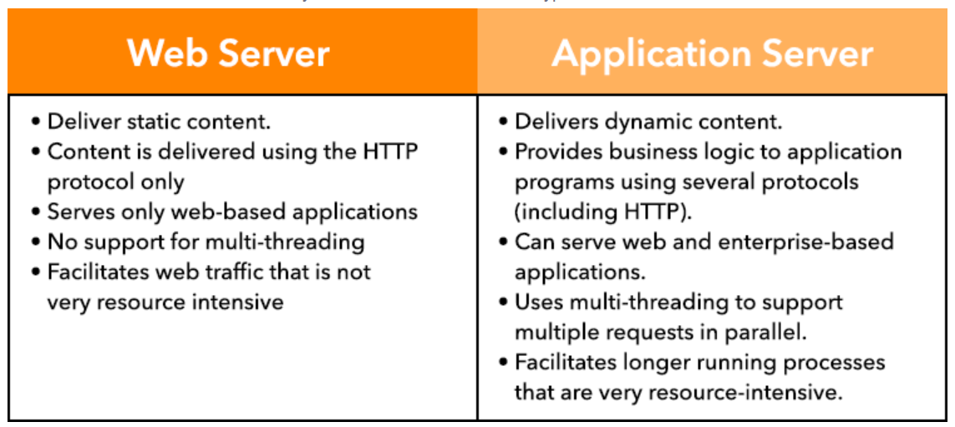

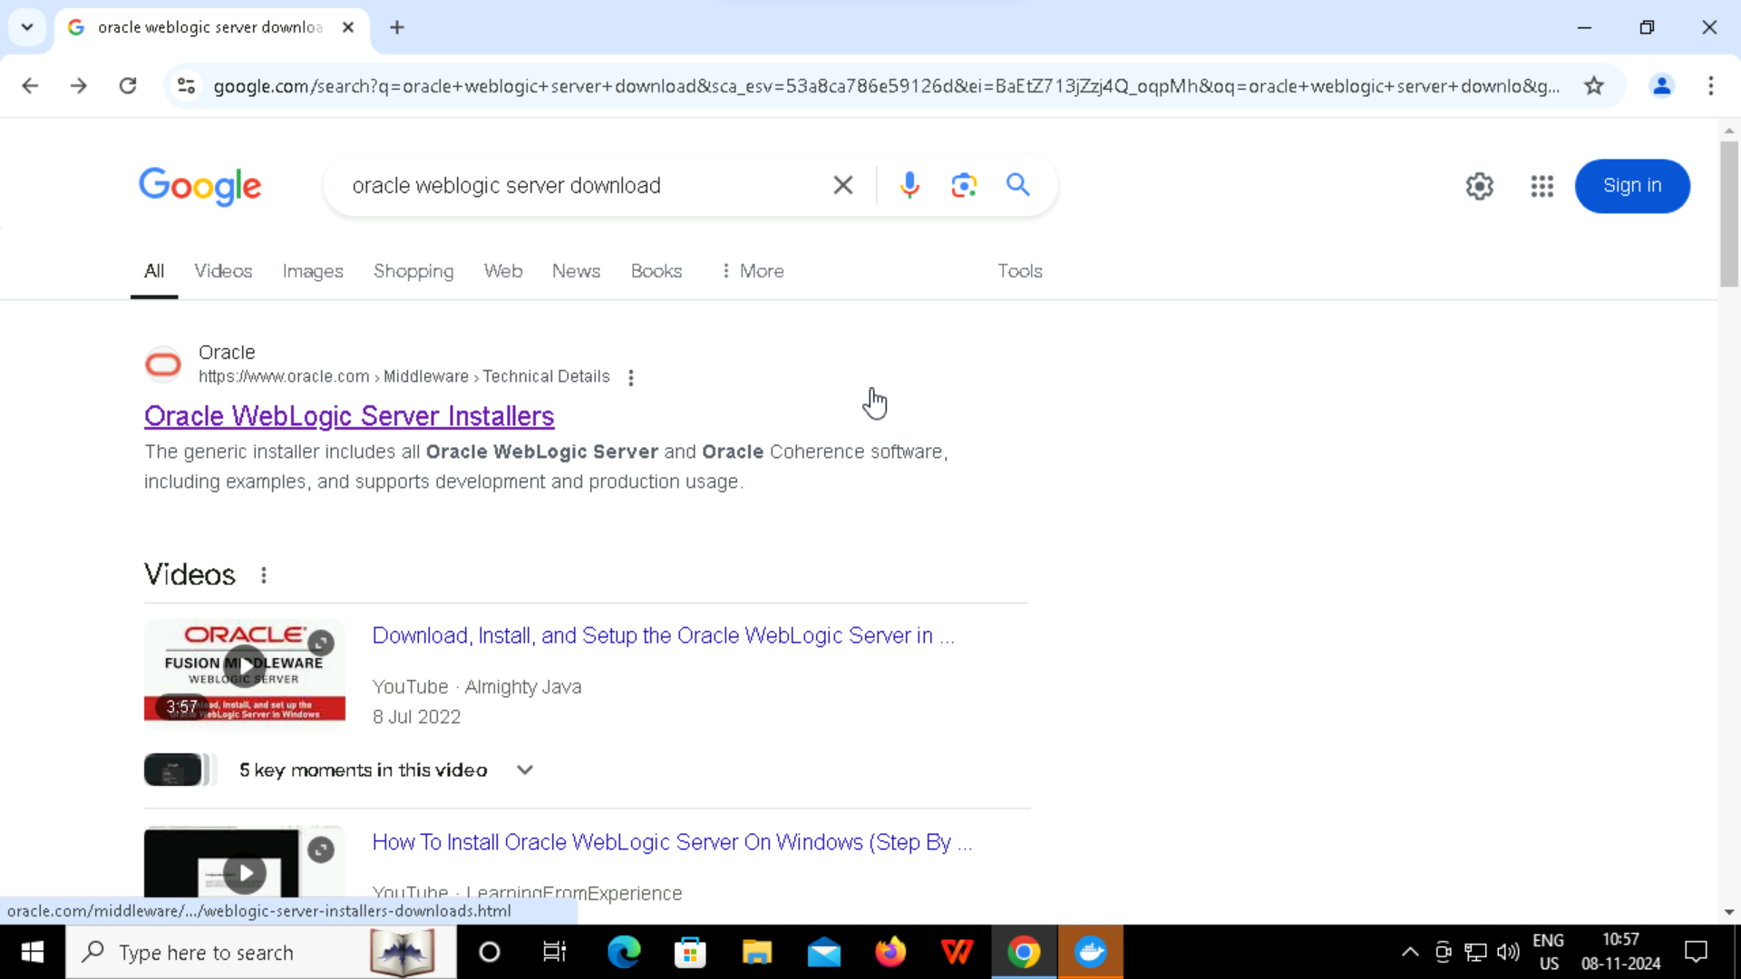

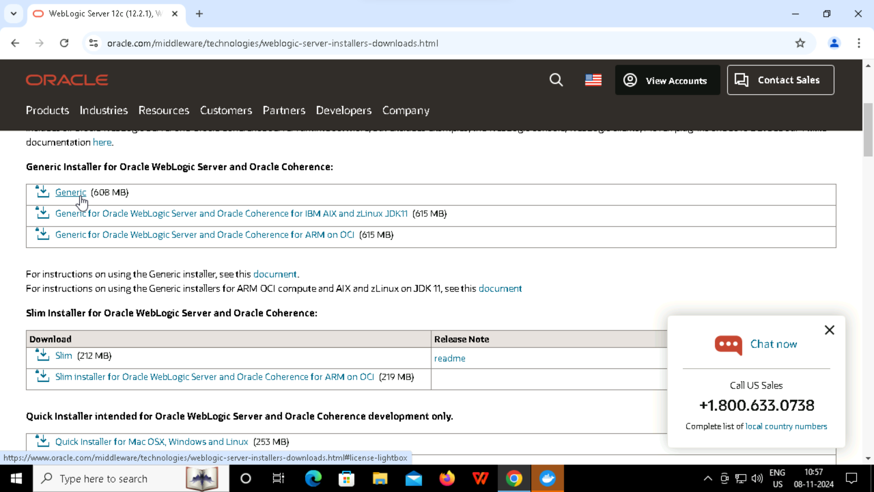

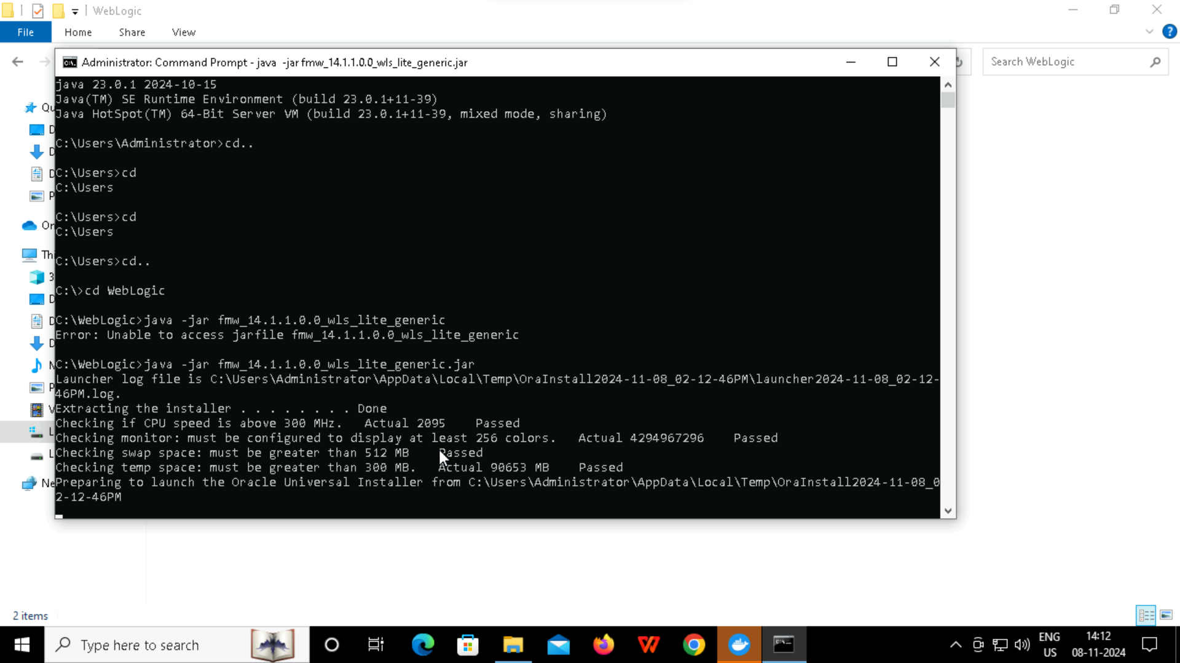

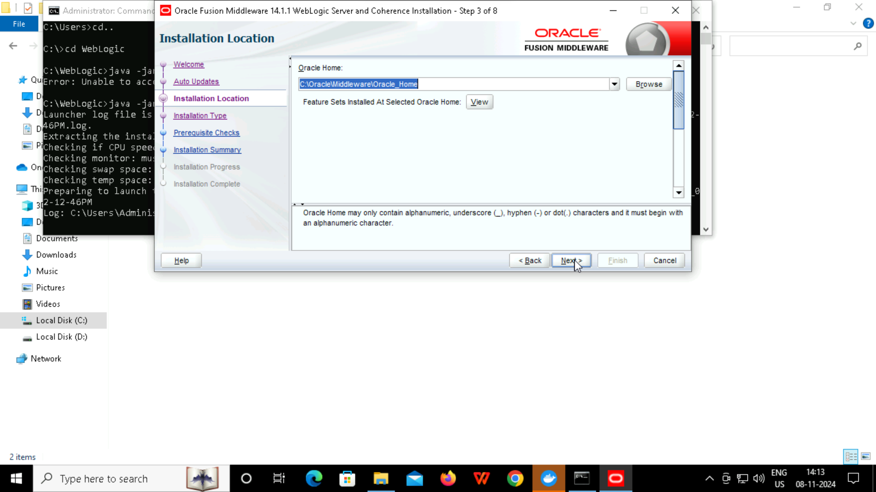

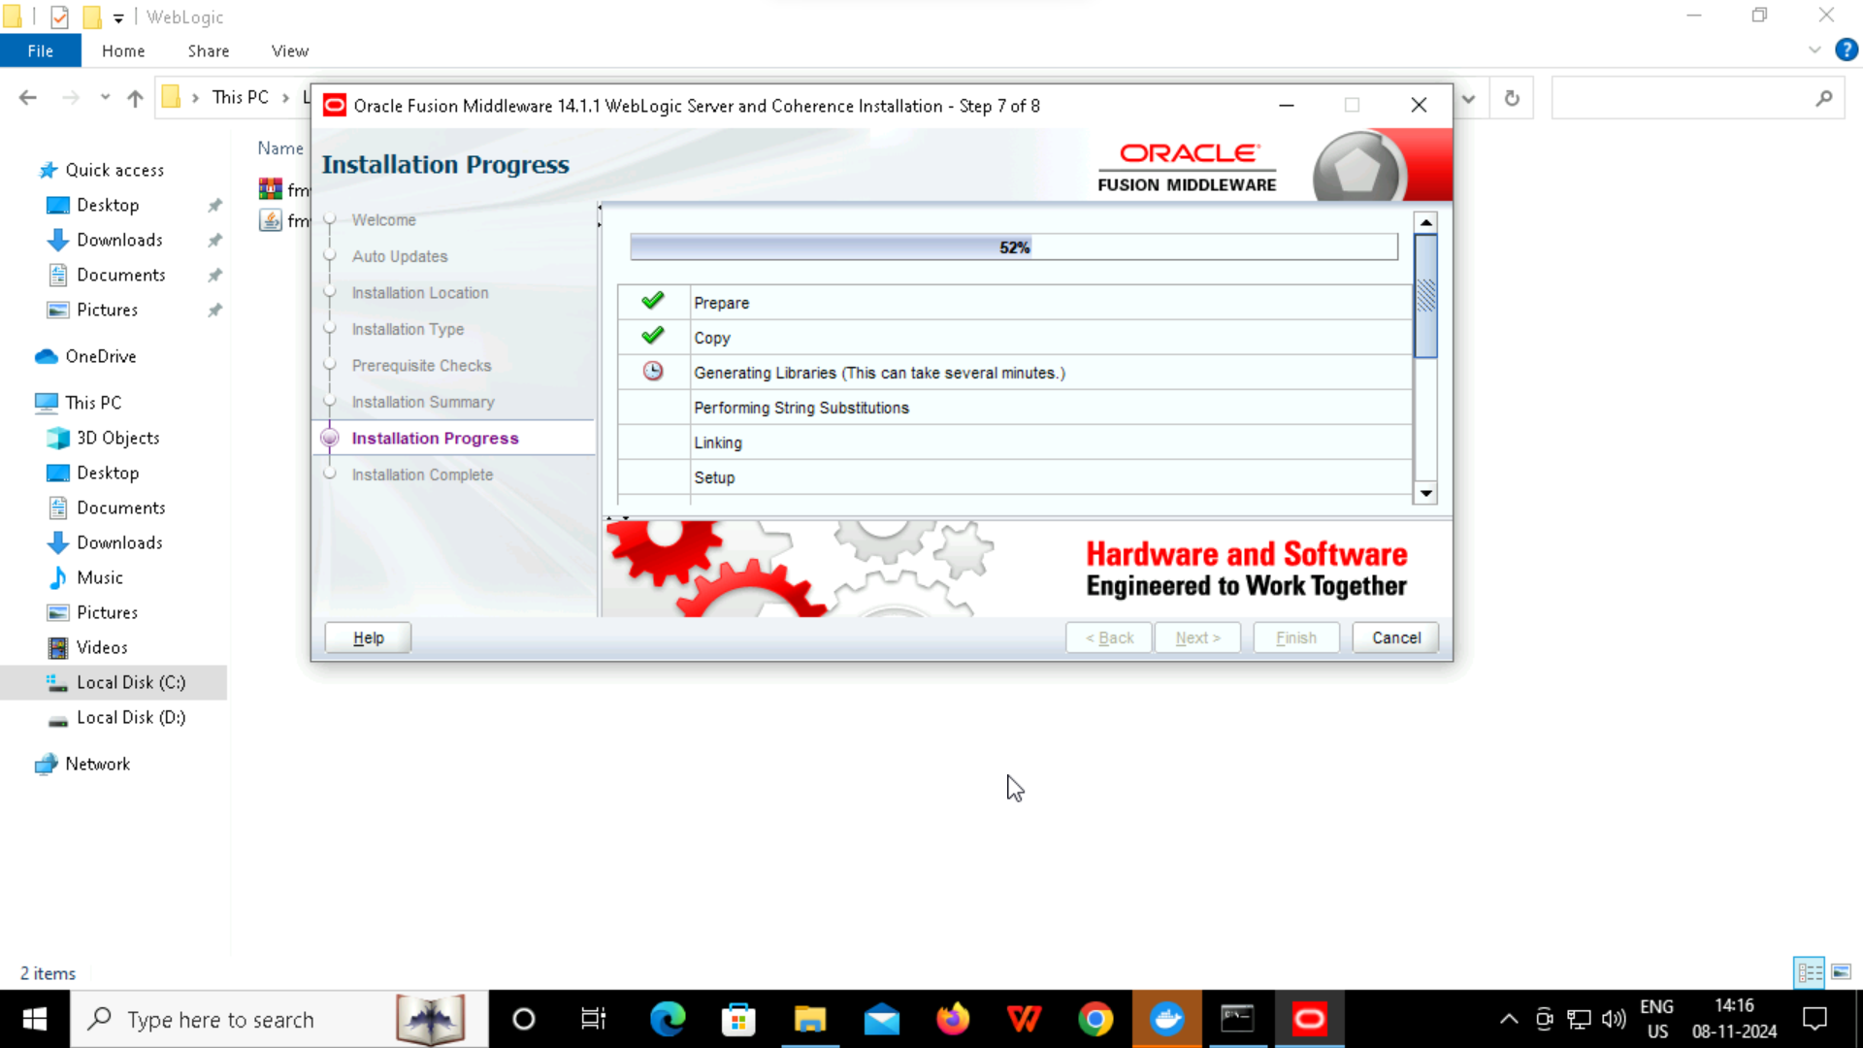

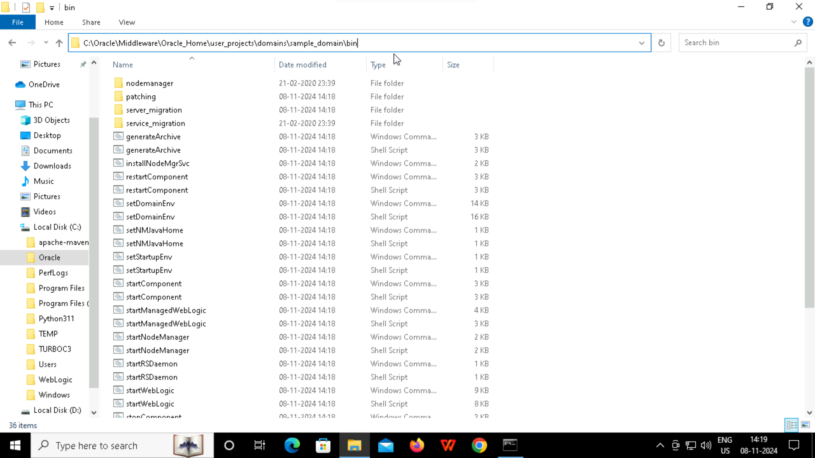

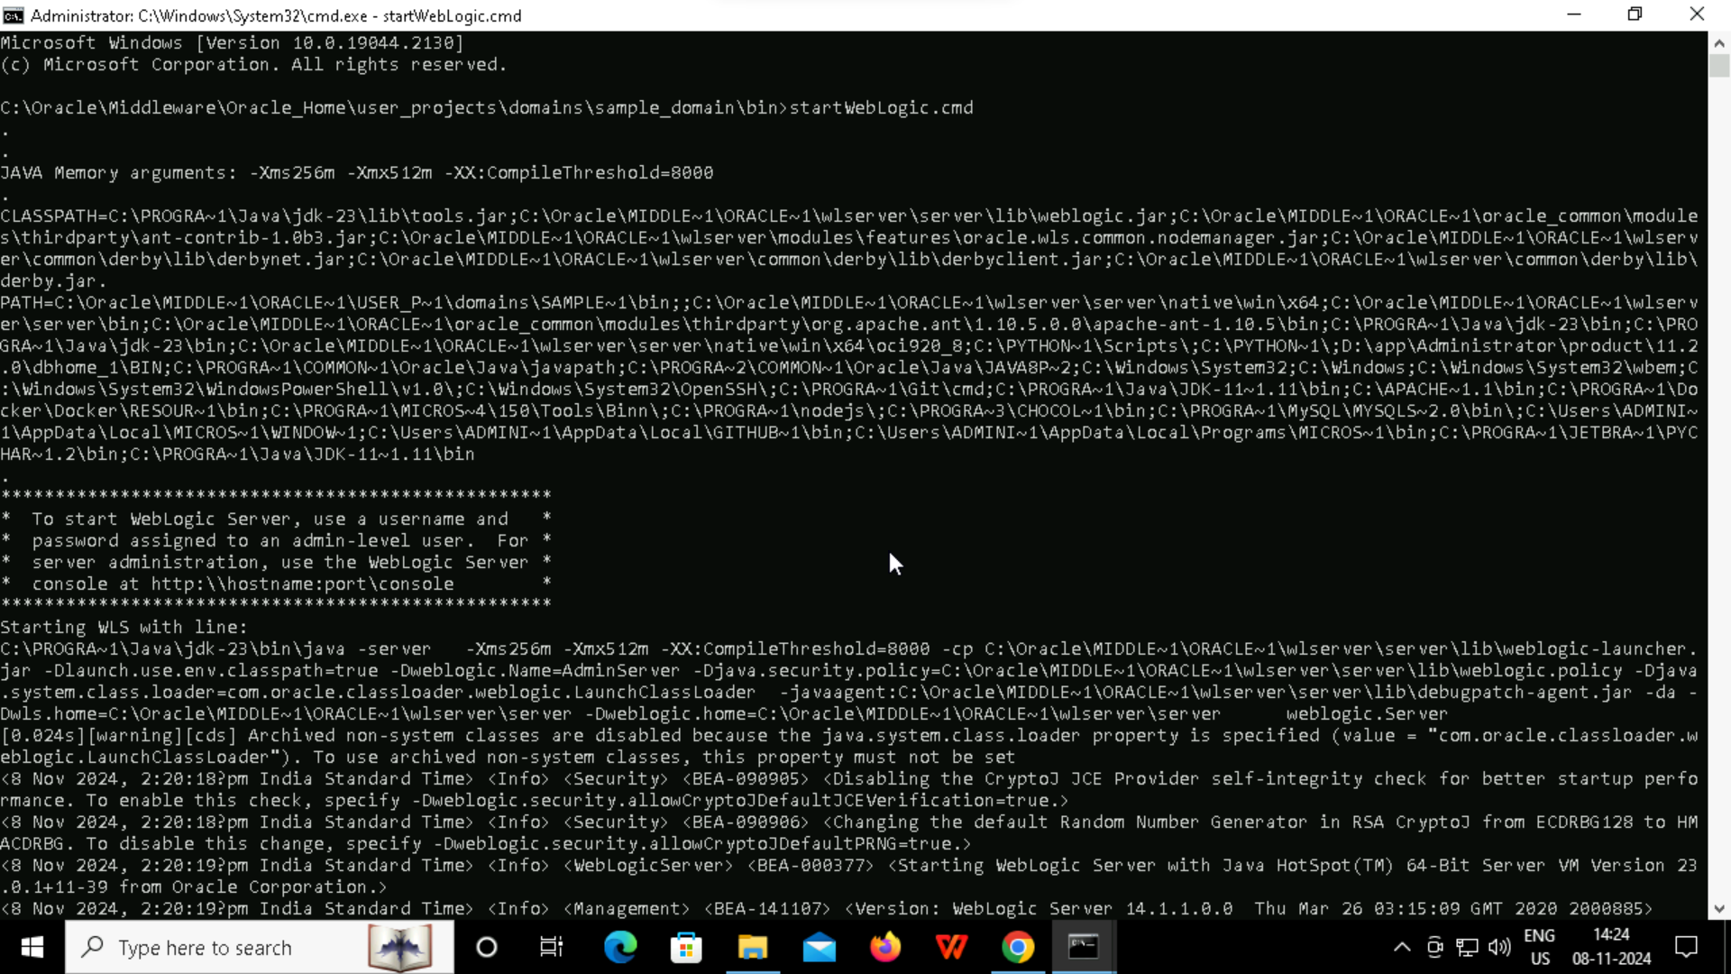

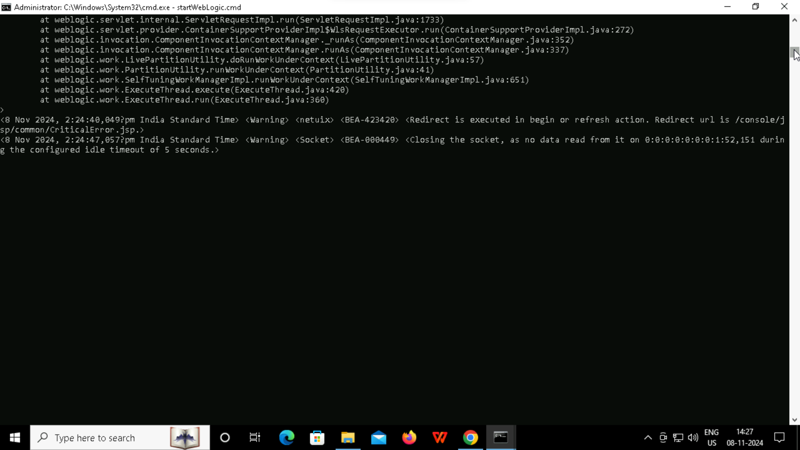

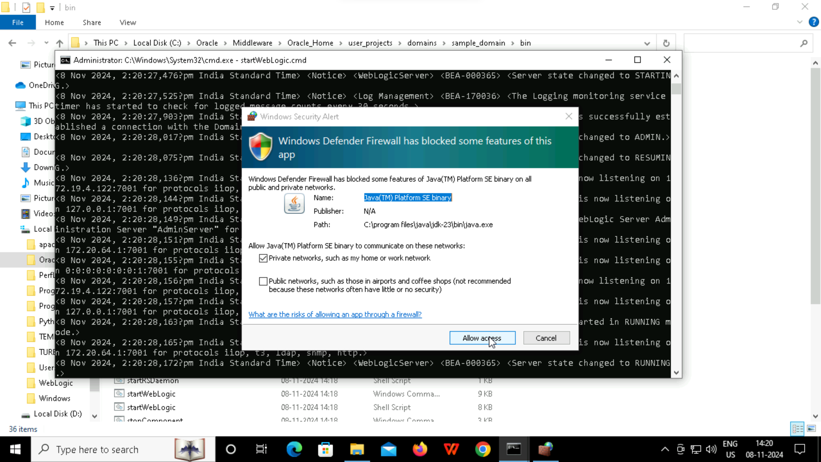

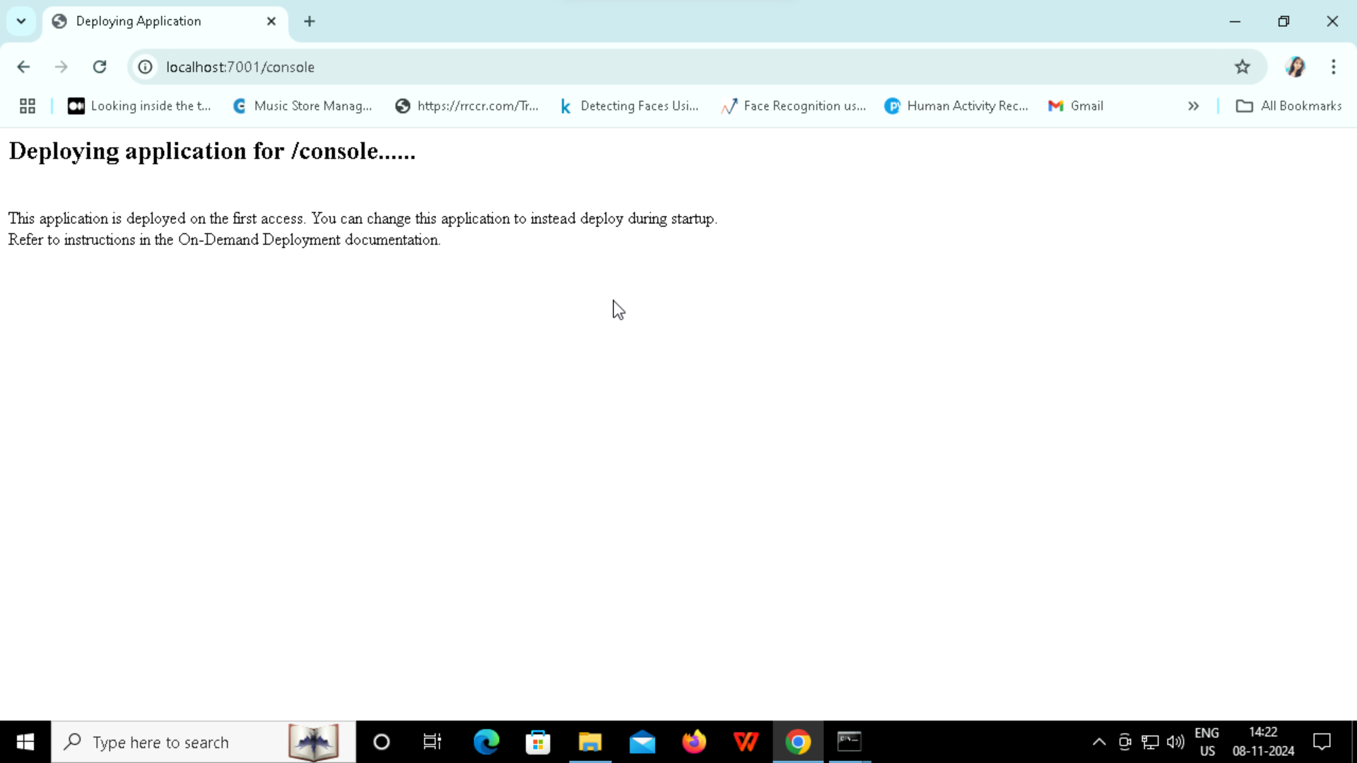

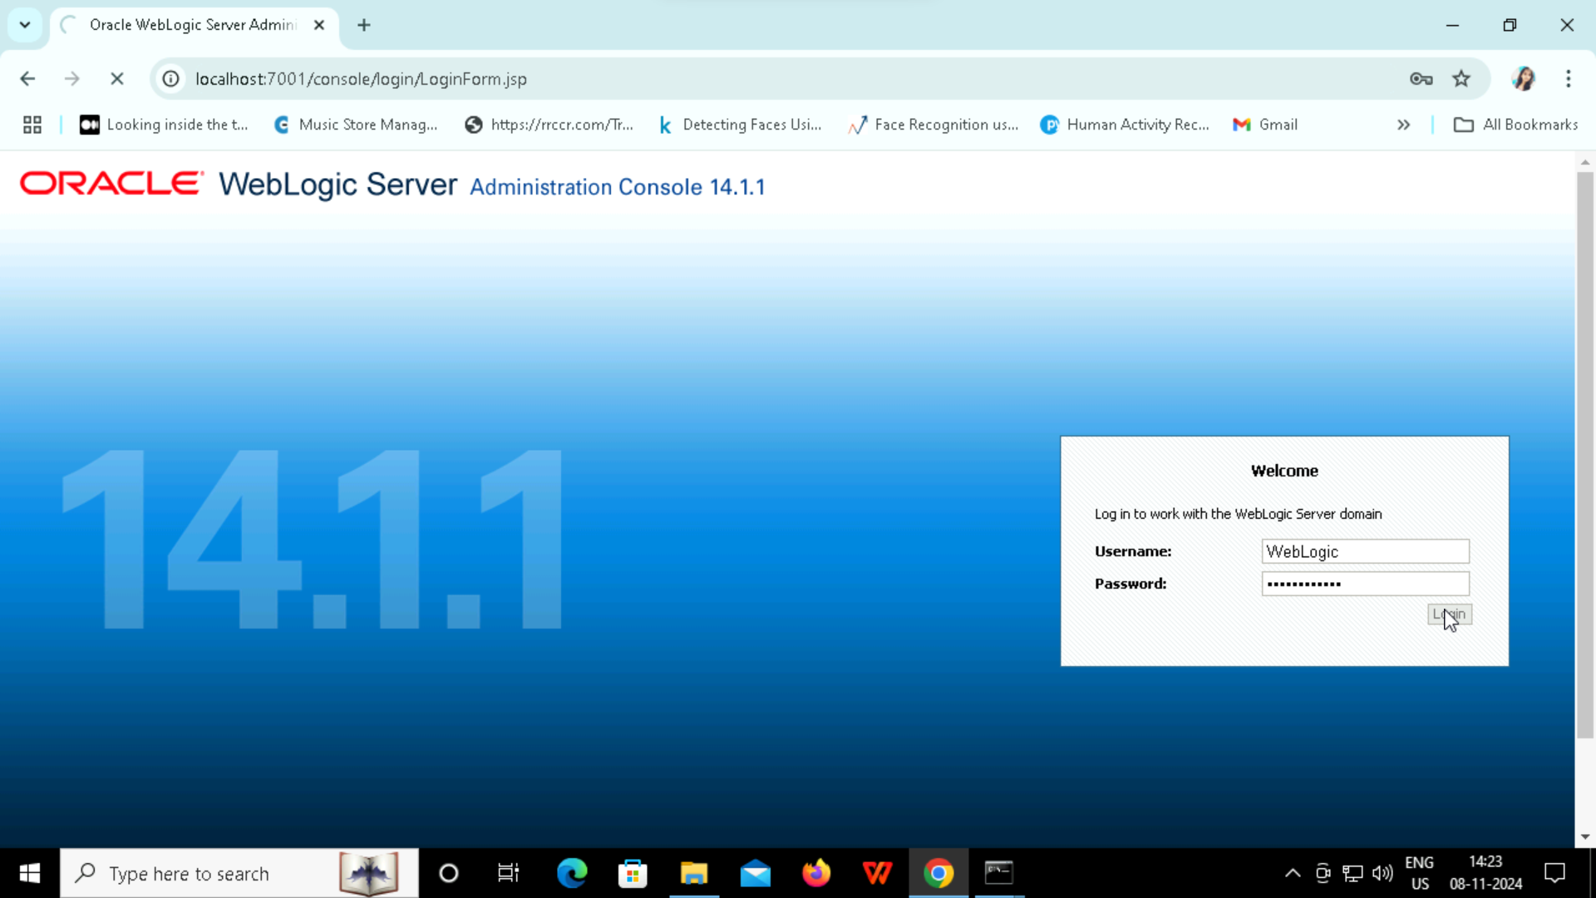

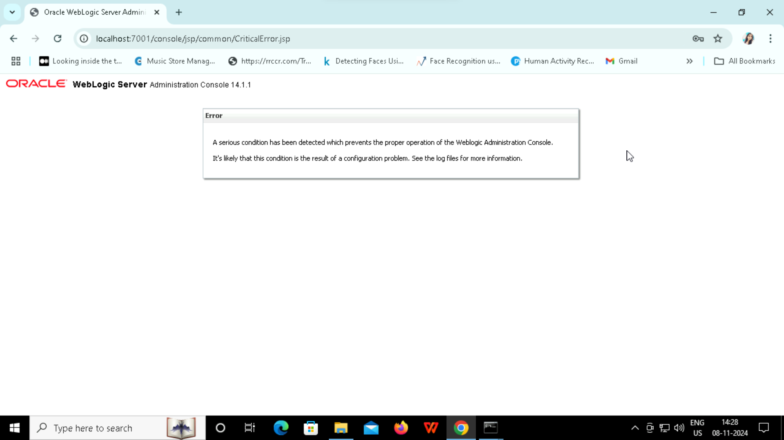

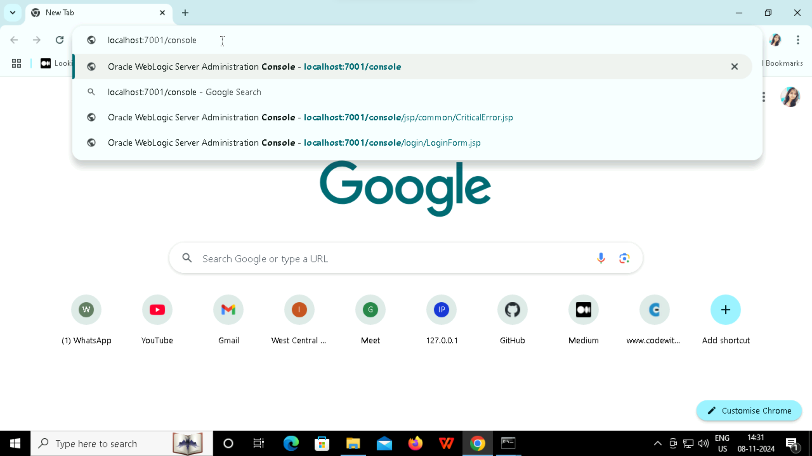

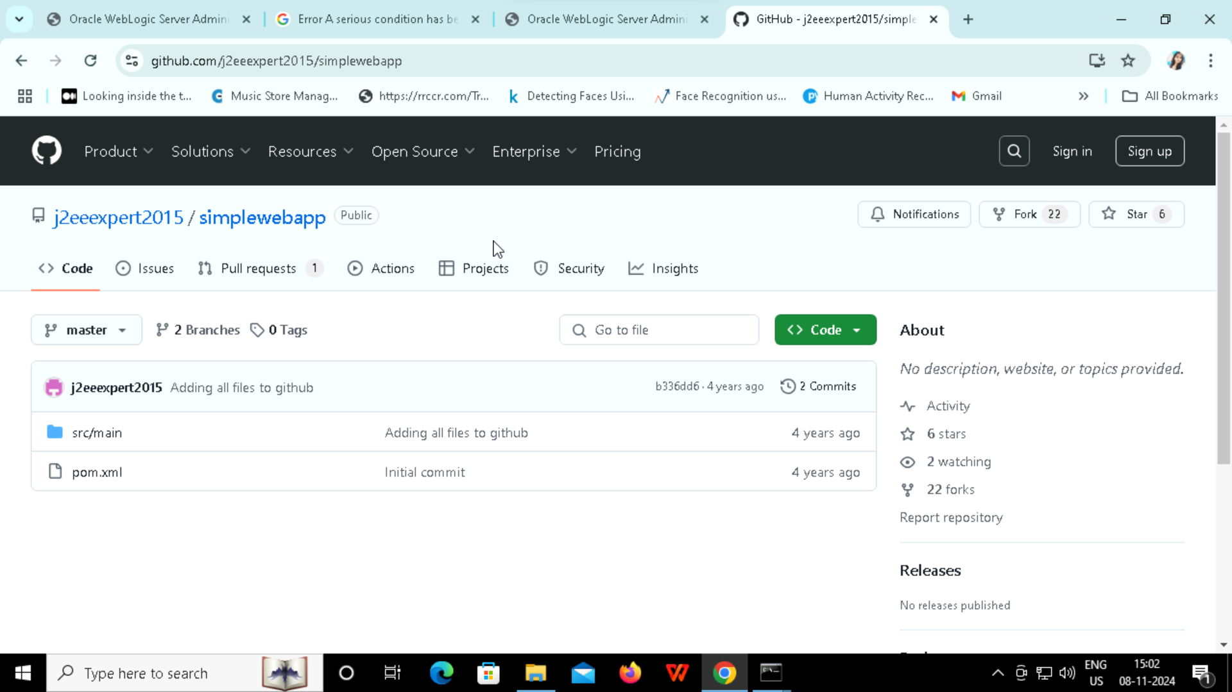

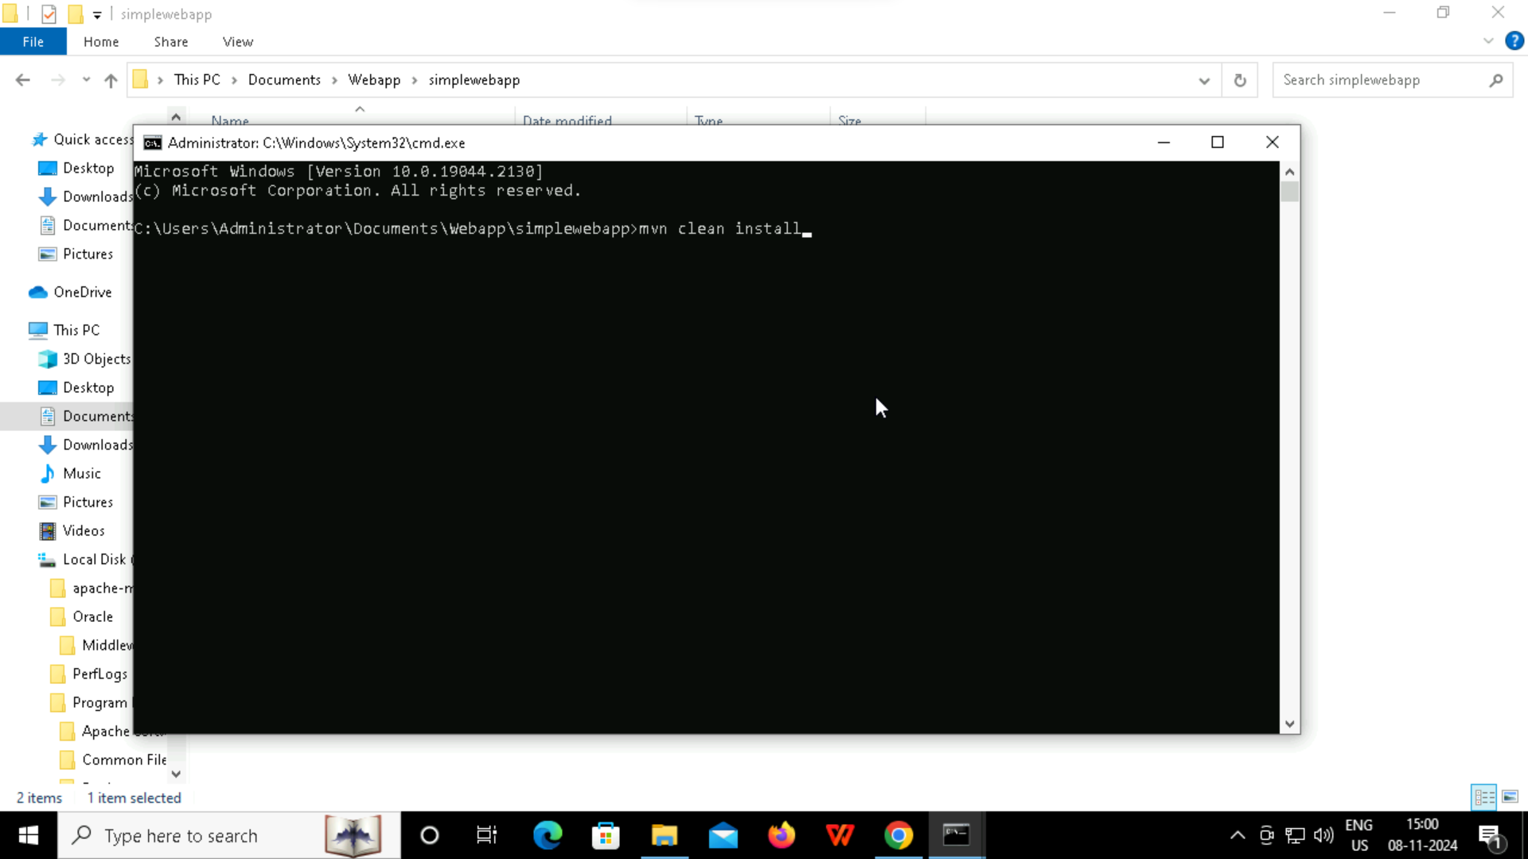

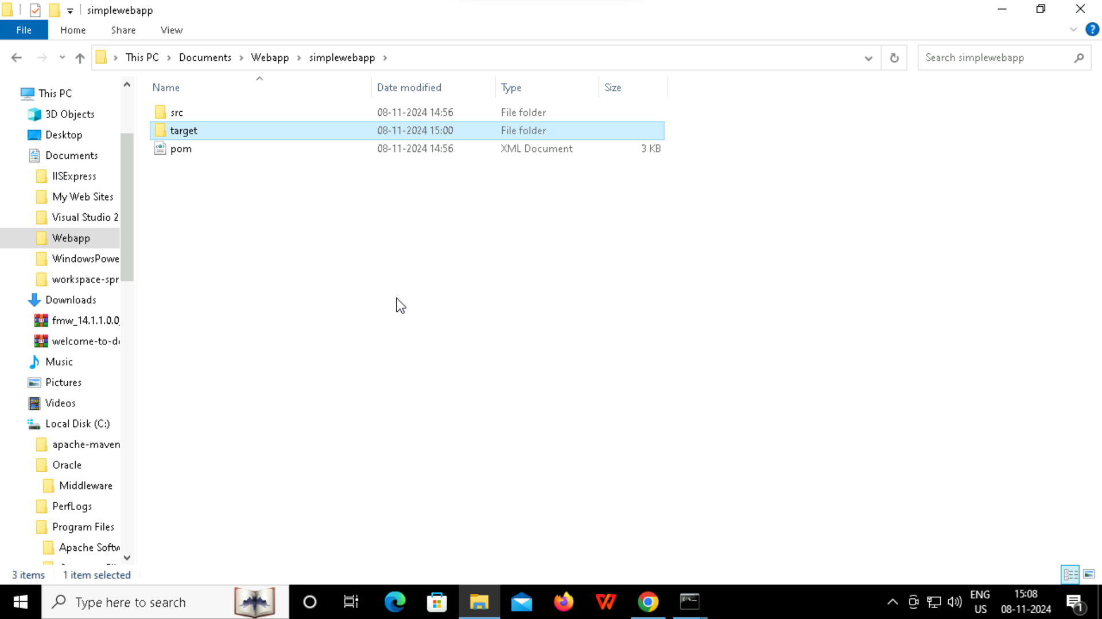

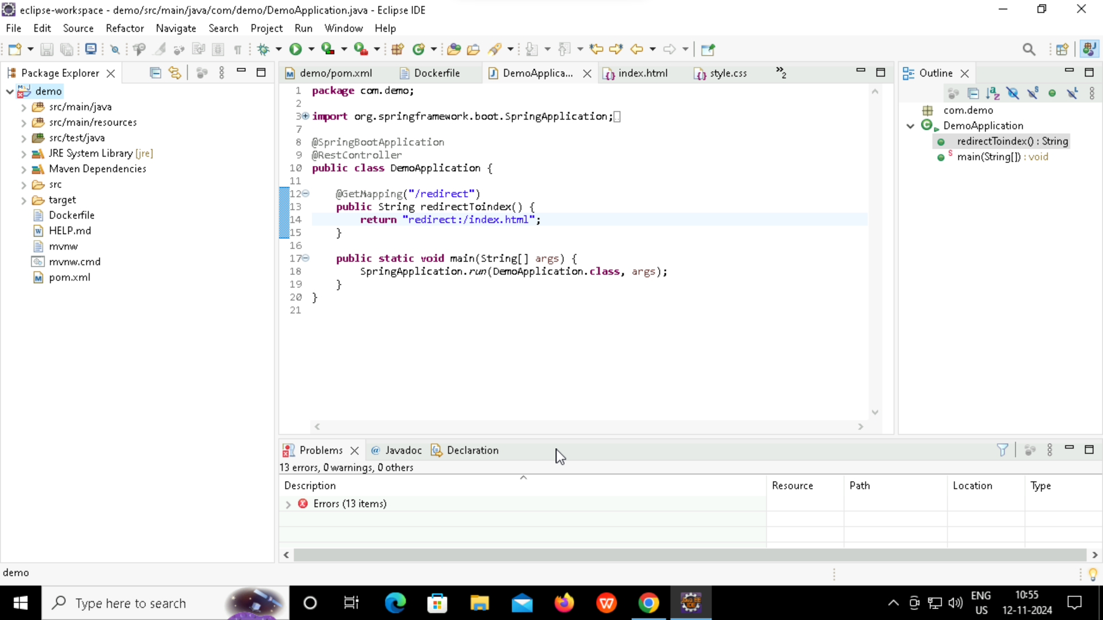

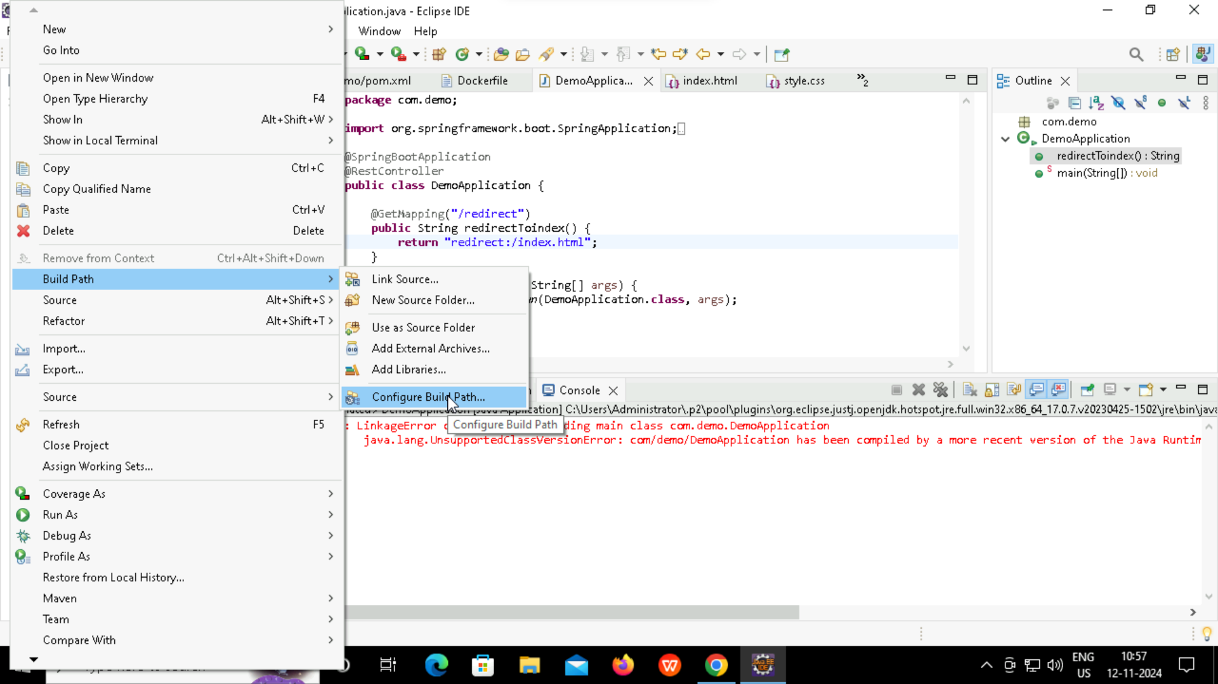

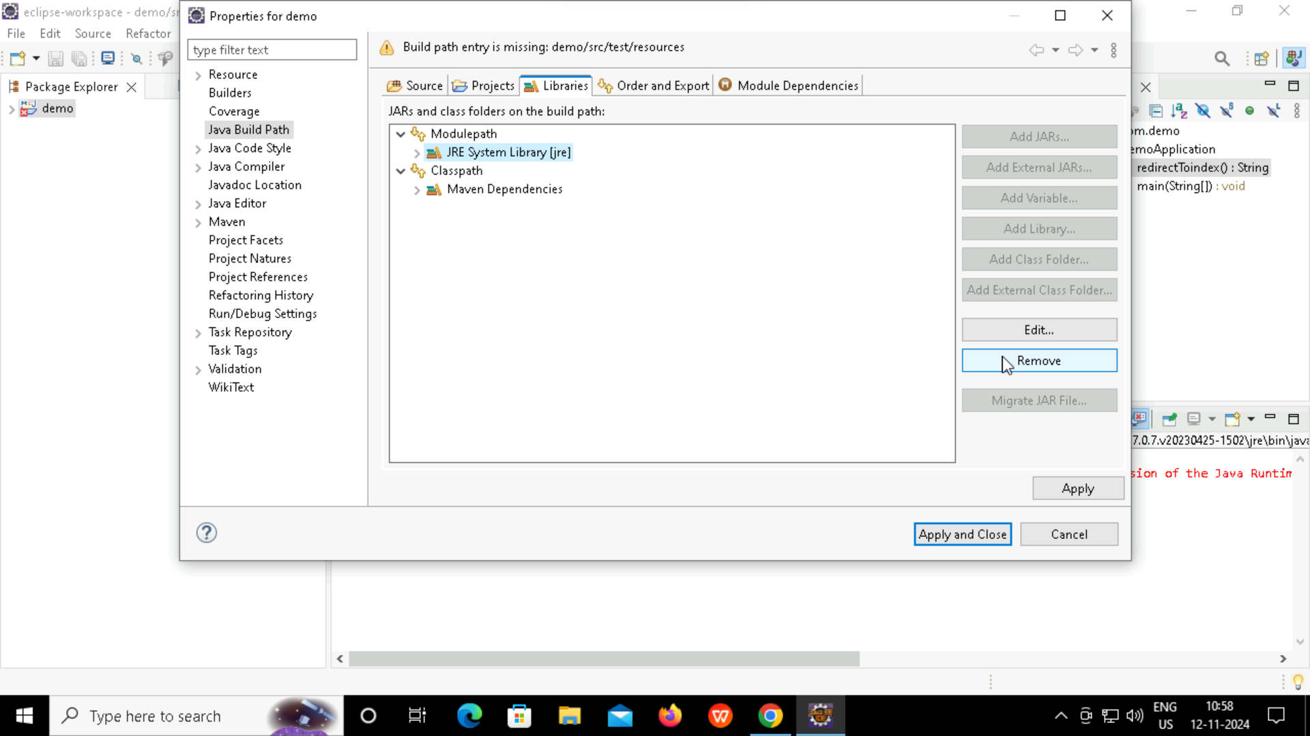

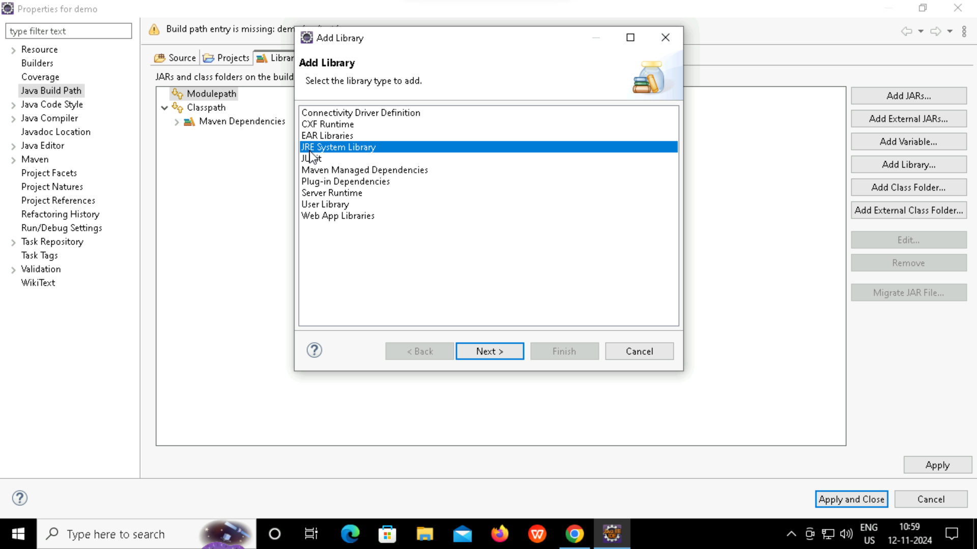

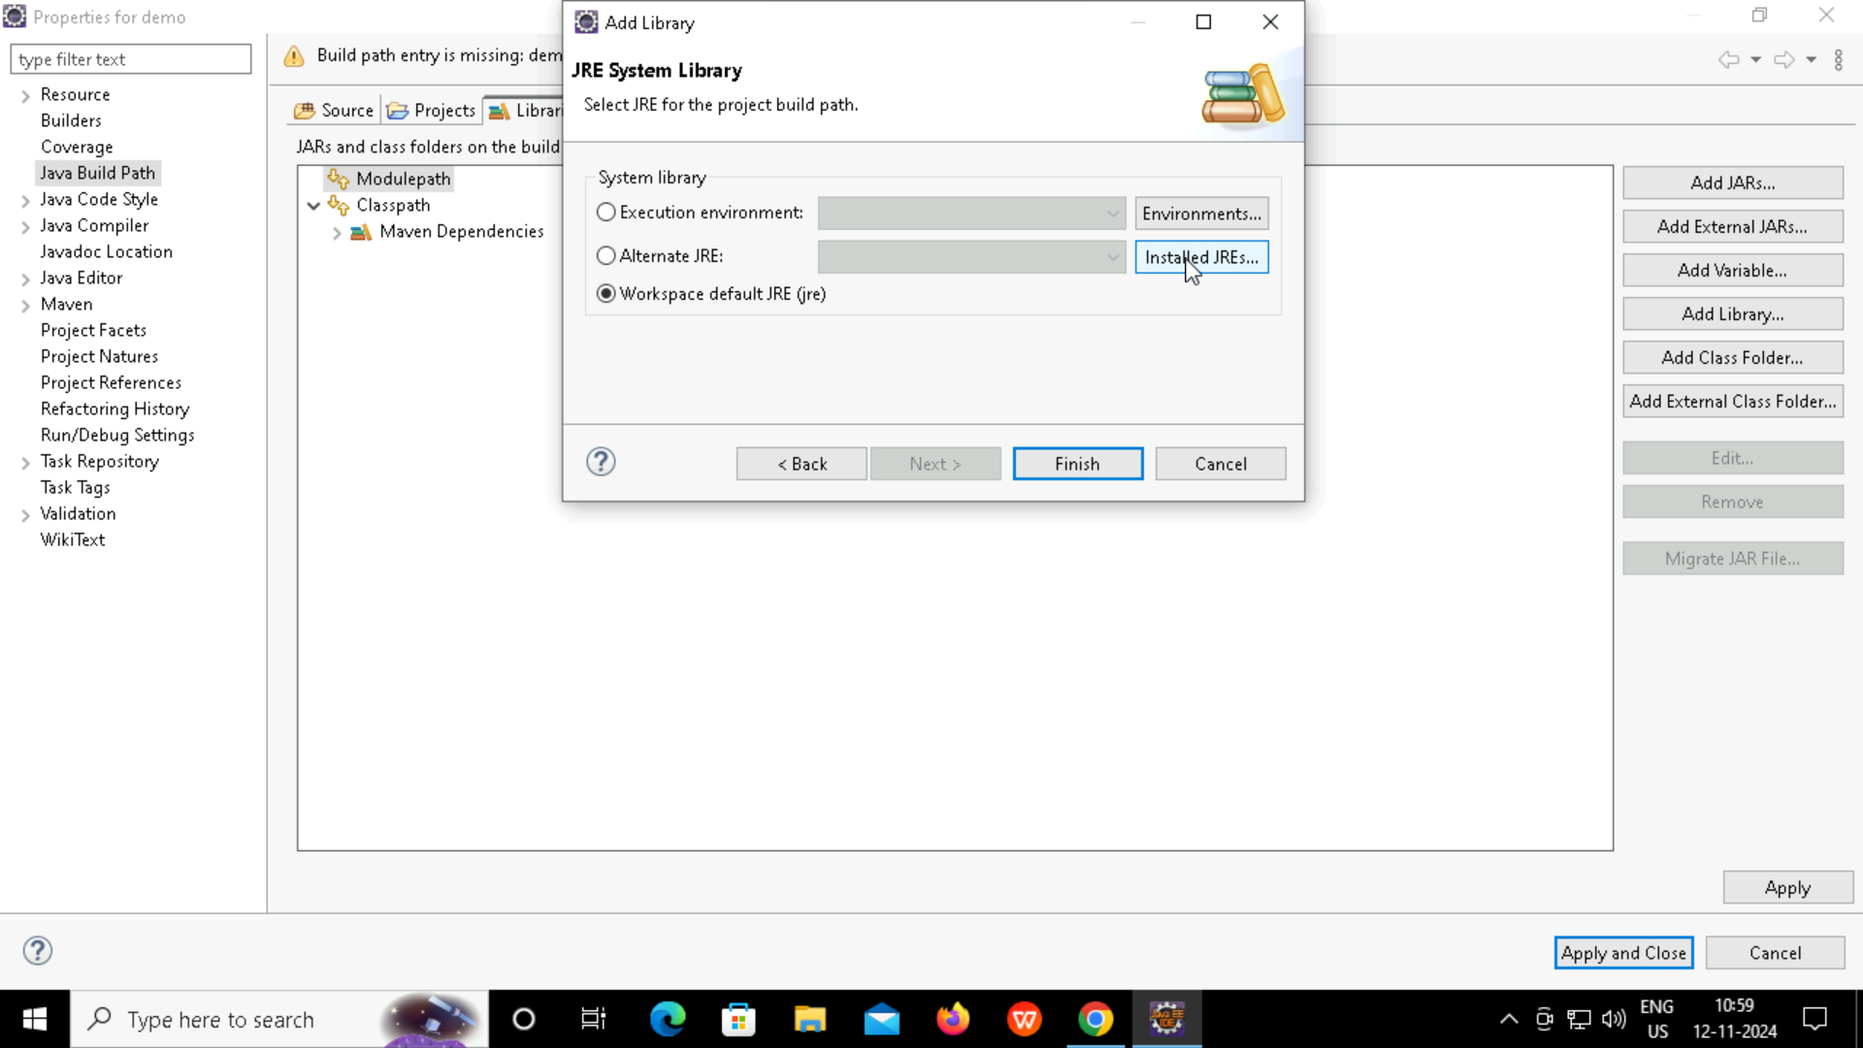

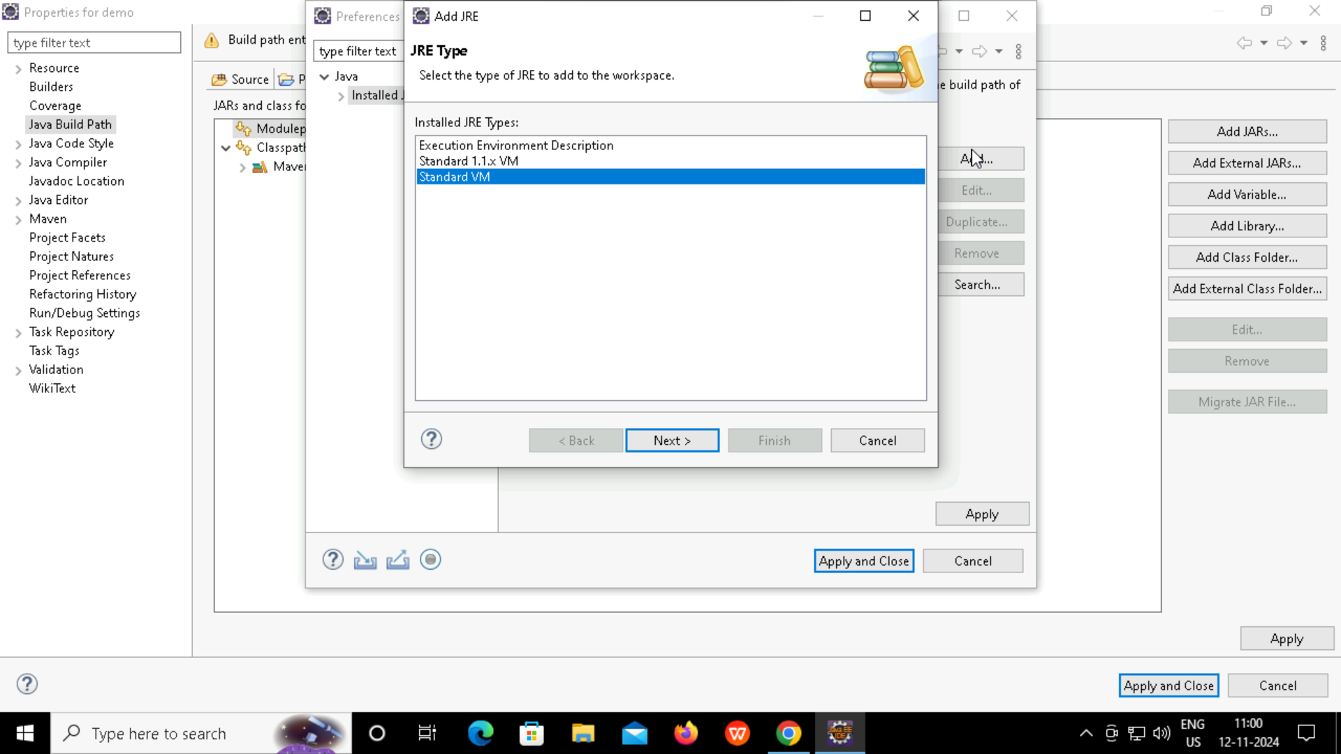

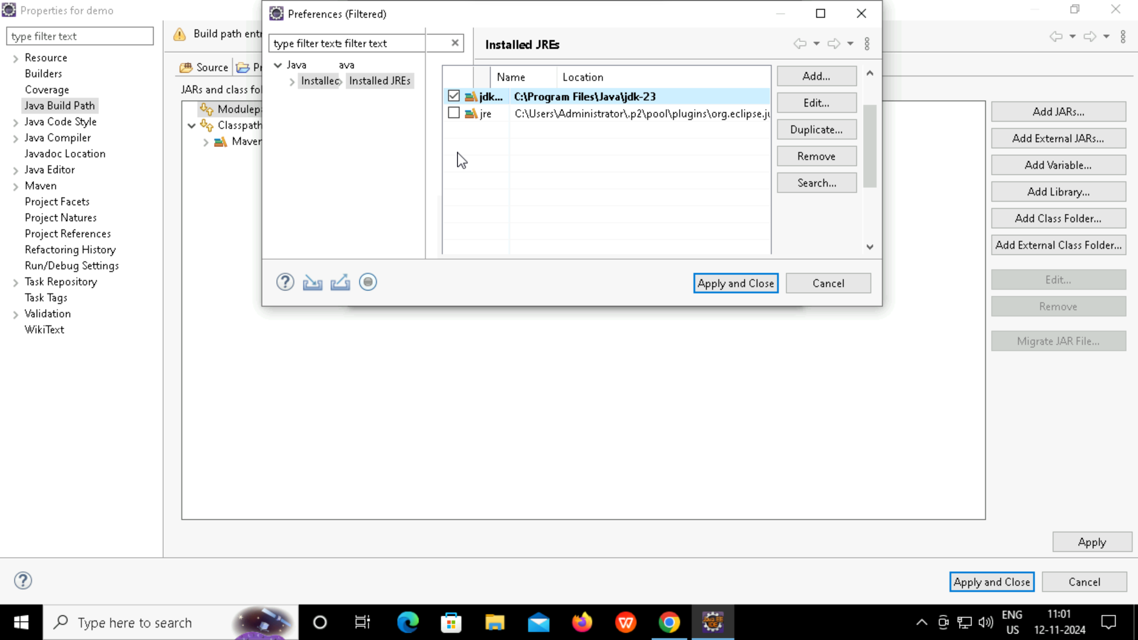

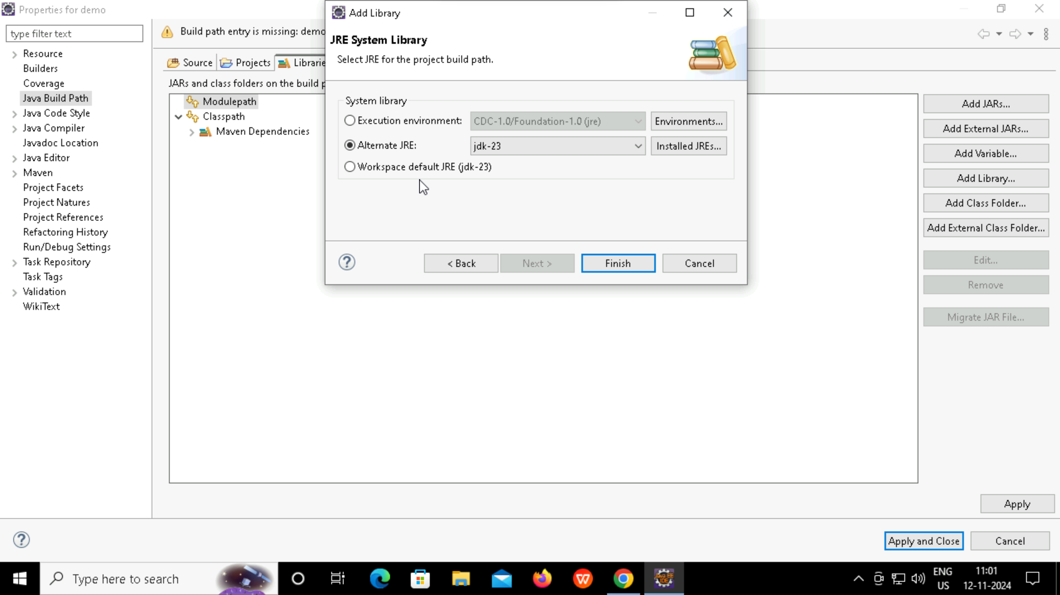

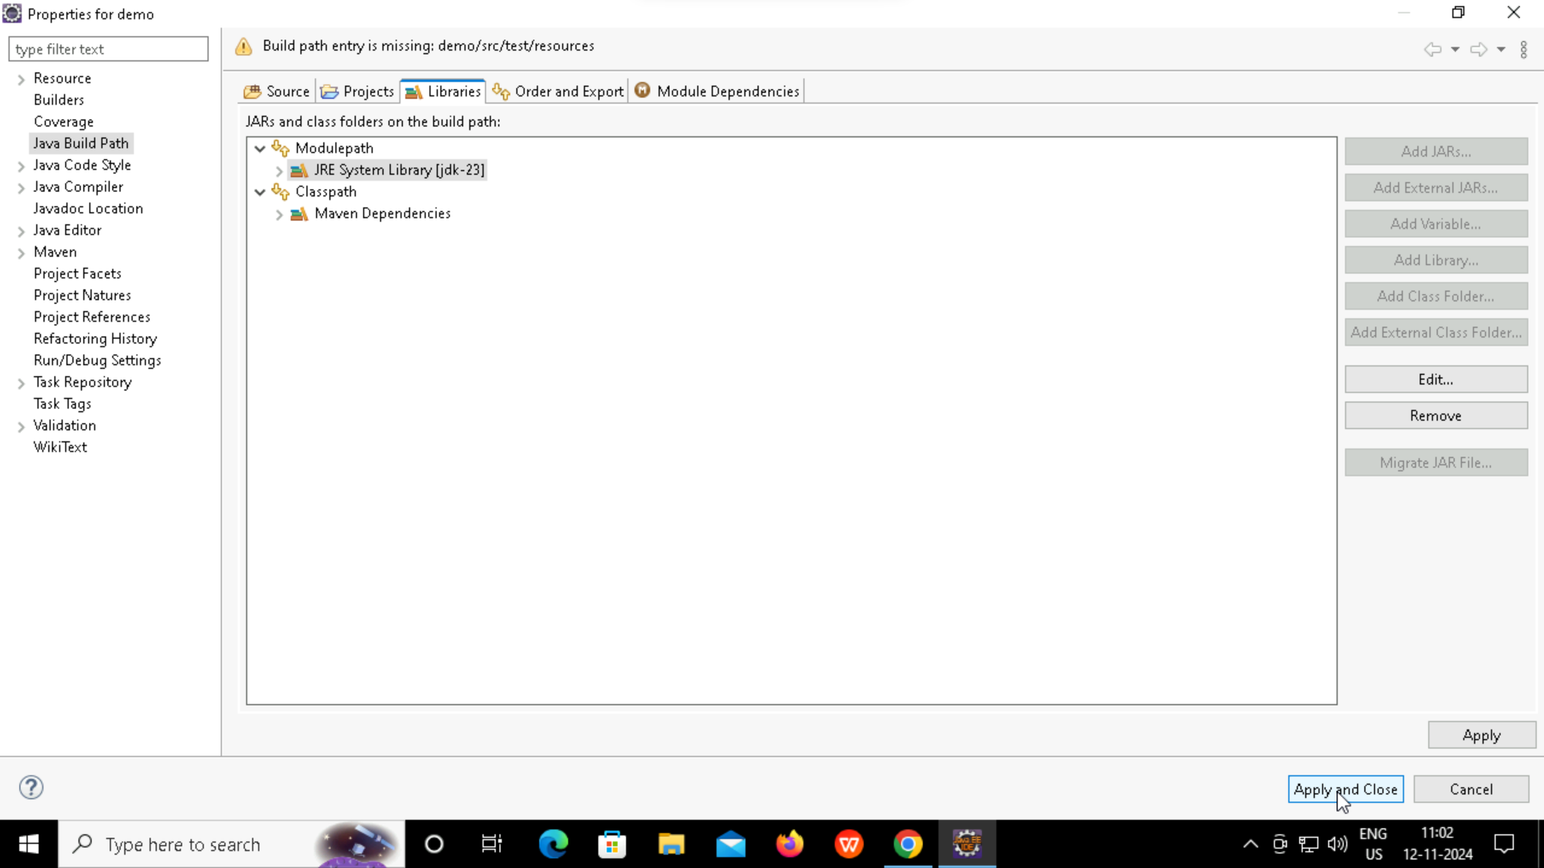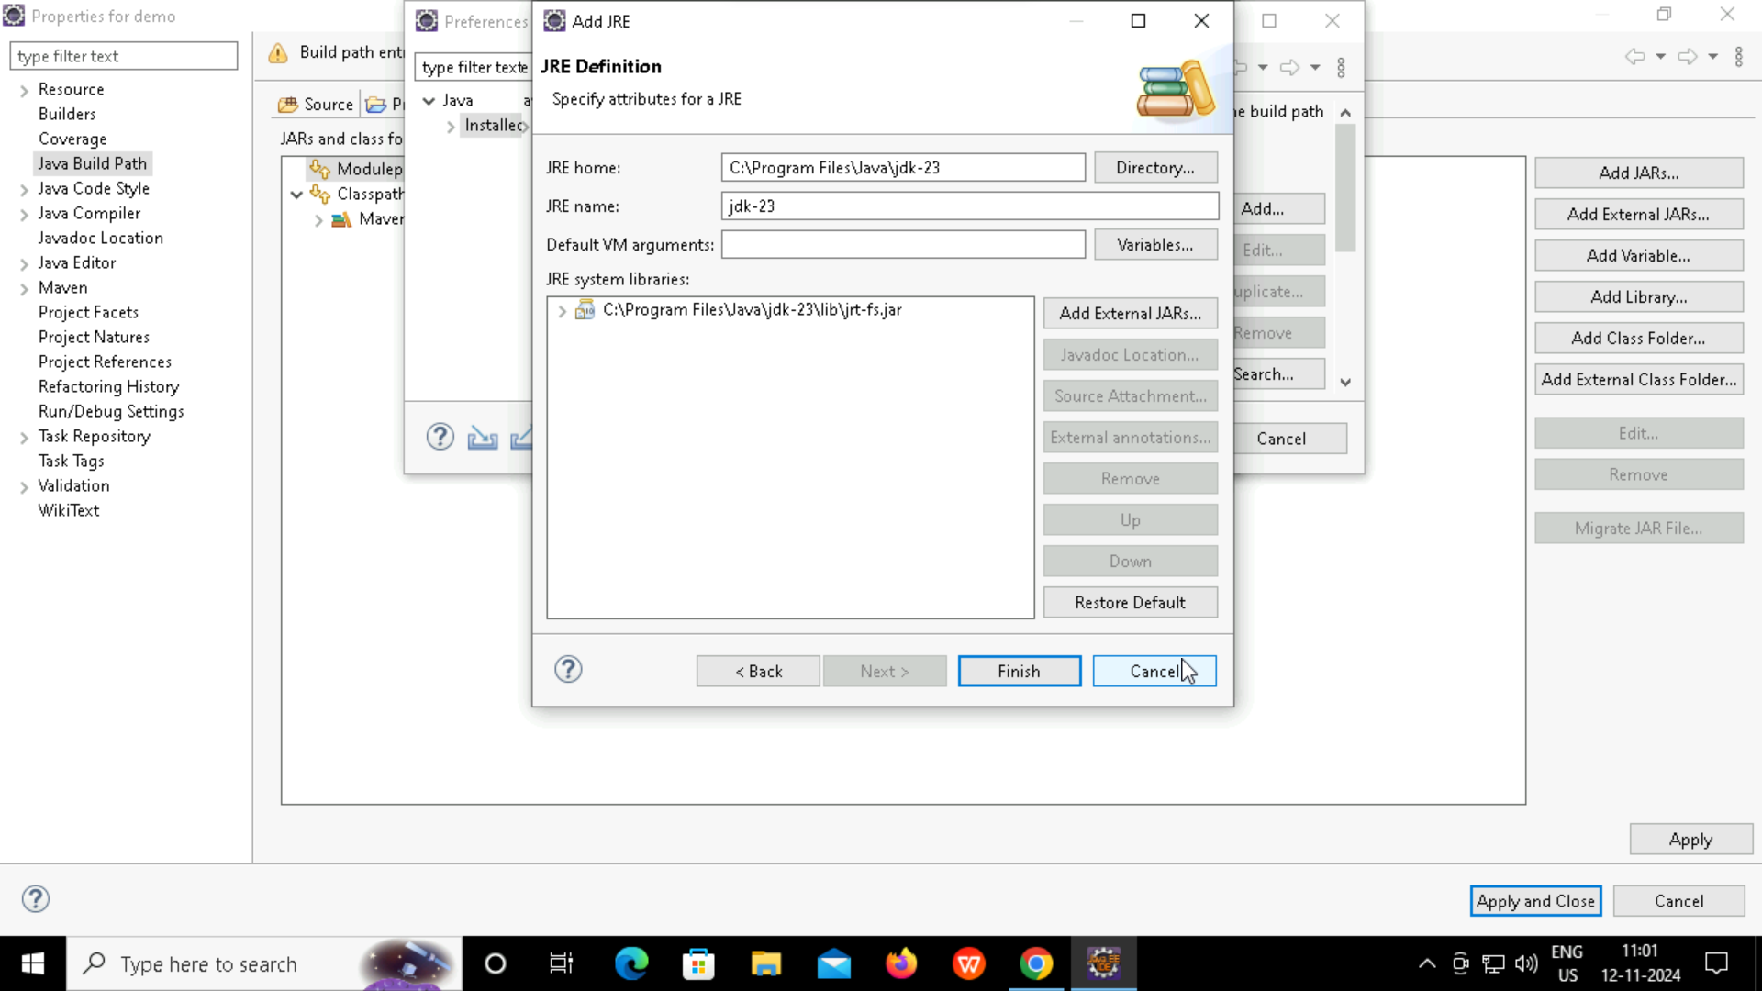

localhost:8080/index.html

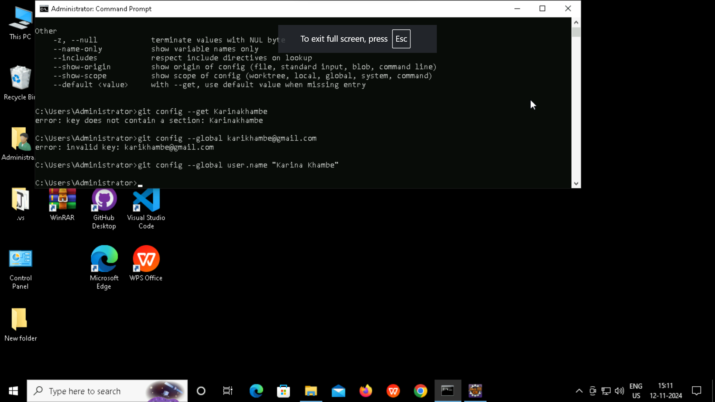

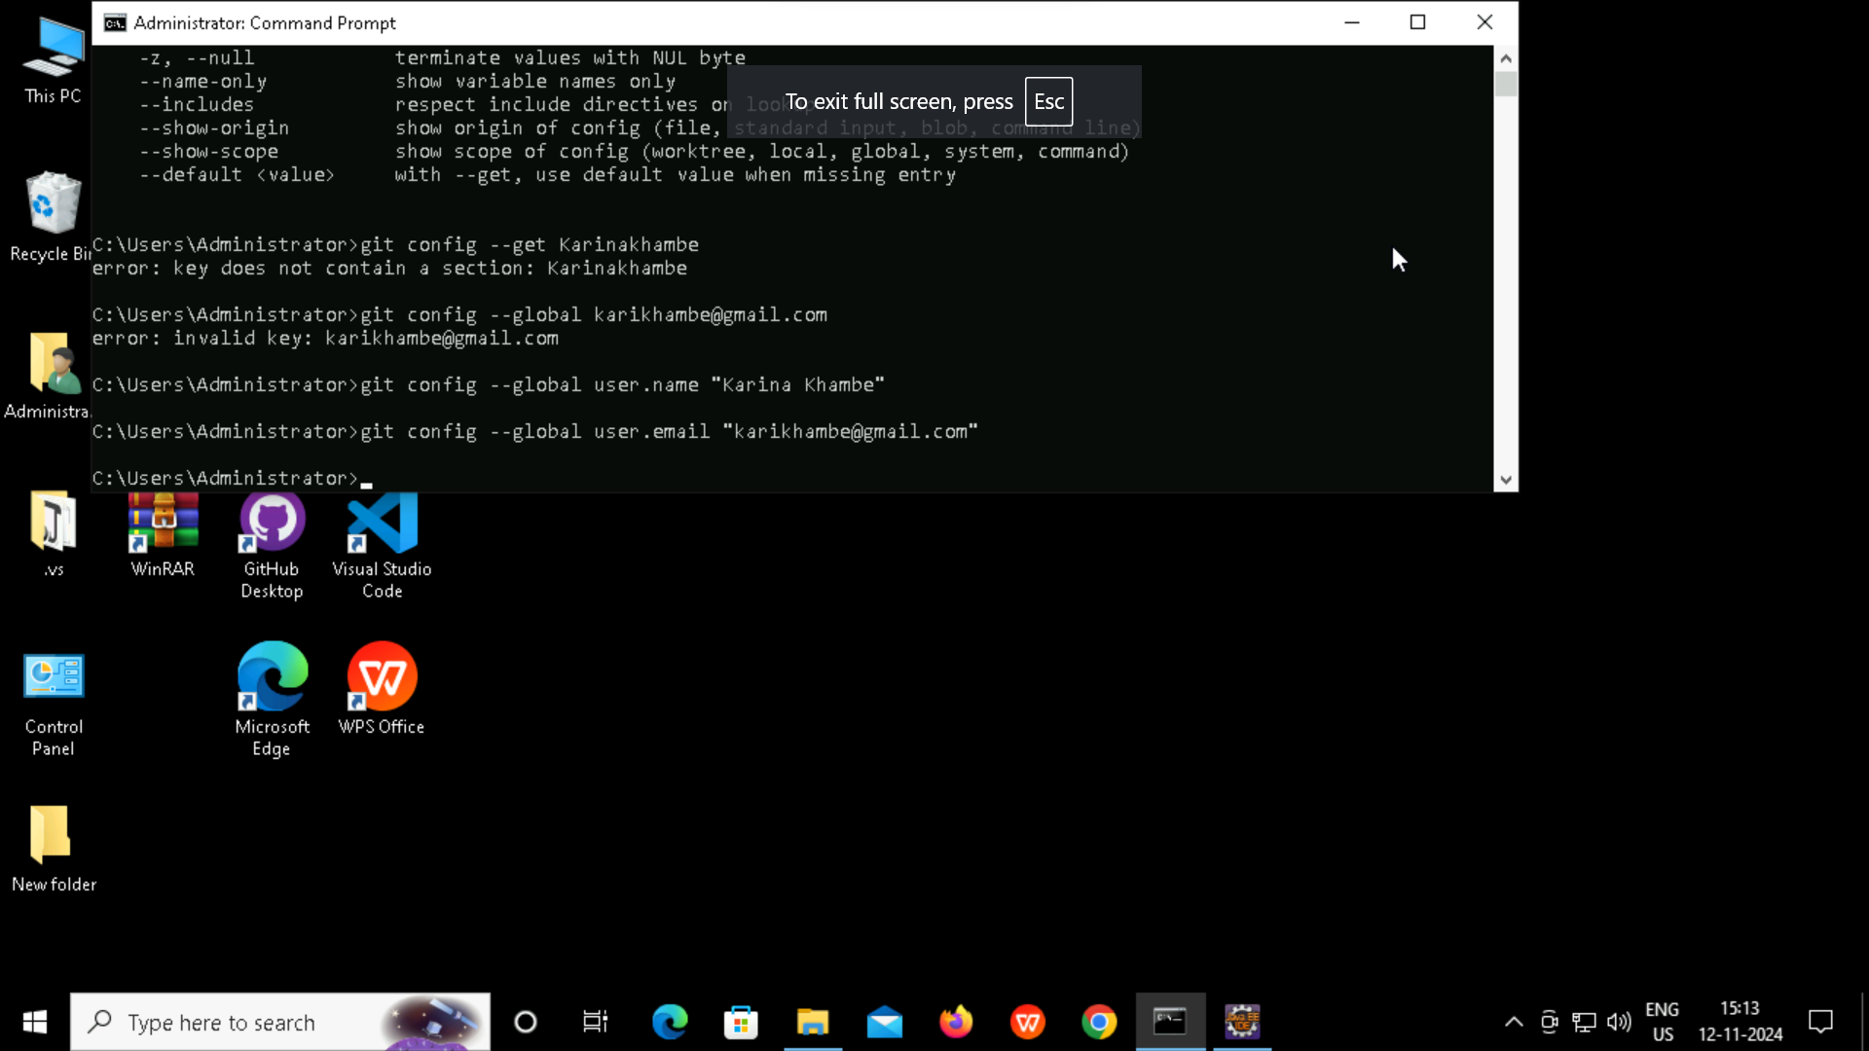

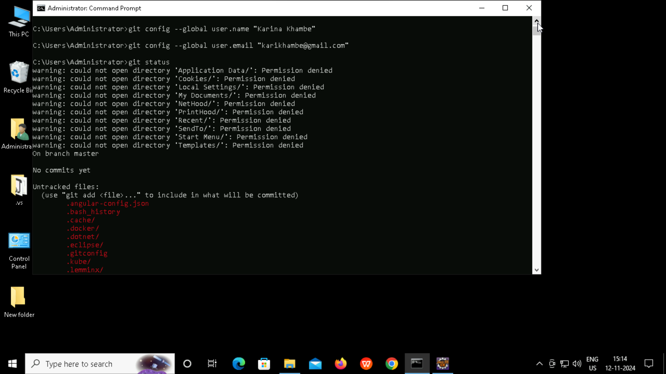

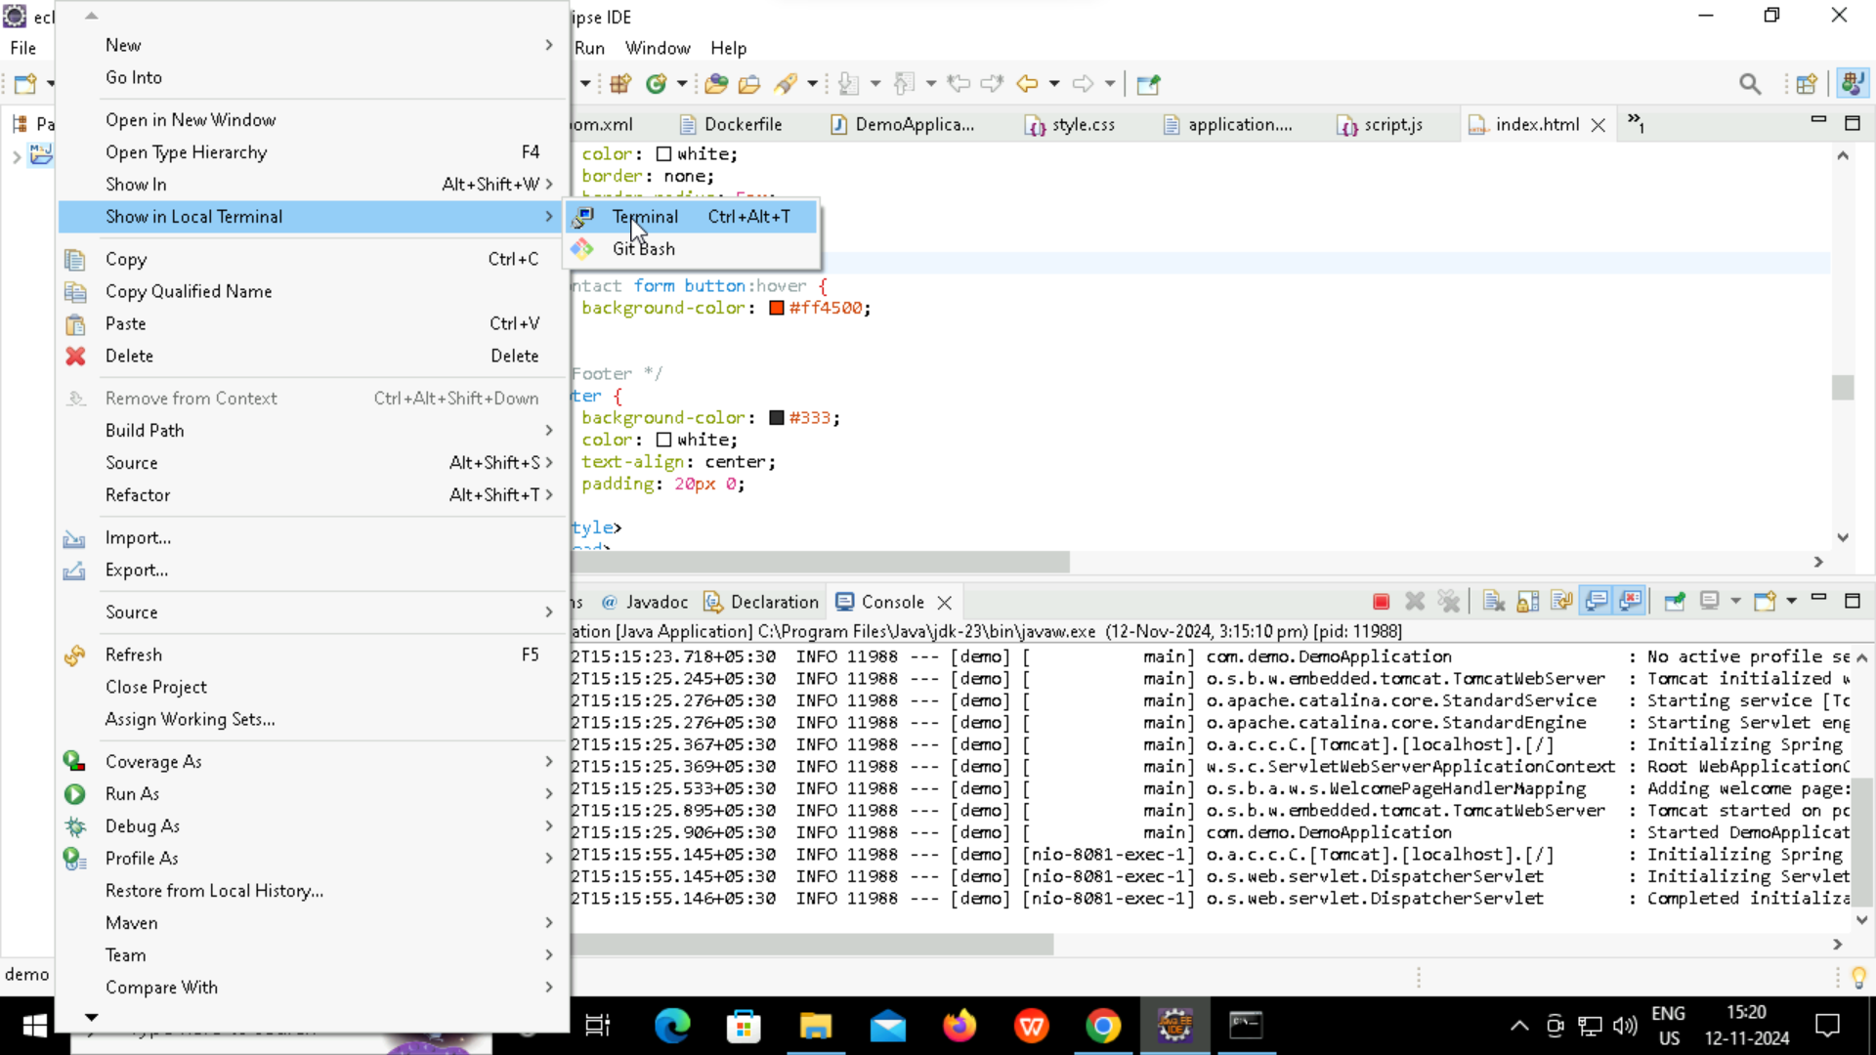

**How to deploy a project using Github and jenkins**

**Git Commands**

git init

git config --global user.name “Karina Khambe”

git config --global user.name [karikhambe@gmail.com](mailto:karikhambe@gmail.com)

git status

git add .

git status

git commit -m “first commit”

git bracnch -M main

git remote add origin gitrepositoryurl

git push -u origin main

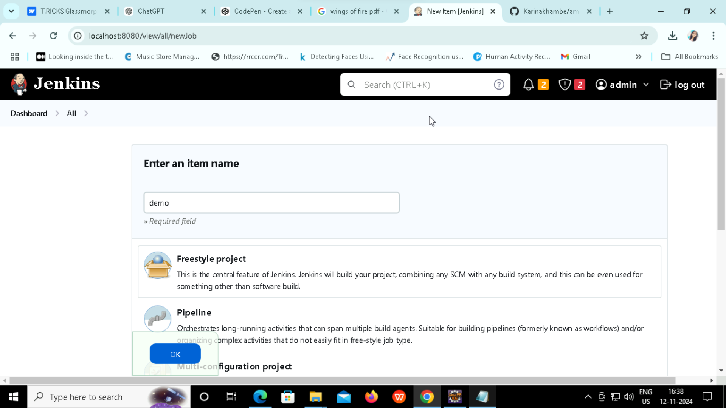

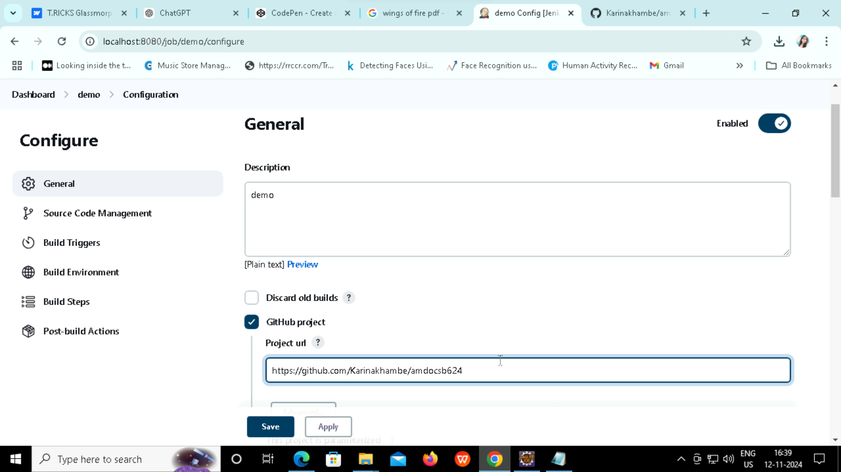

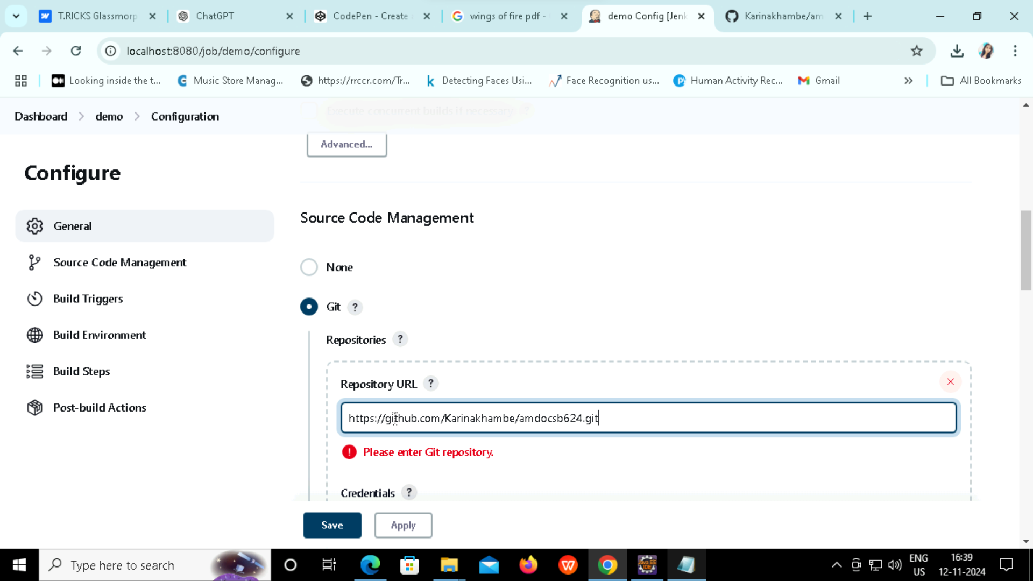

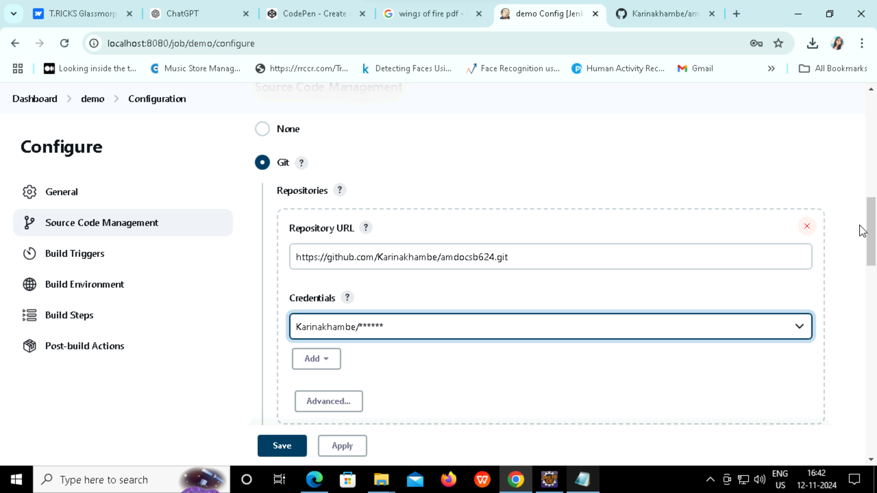

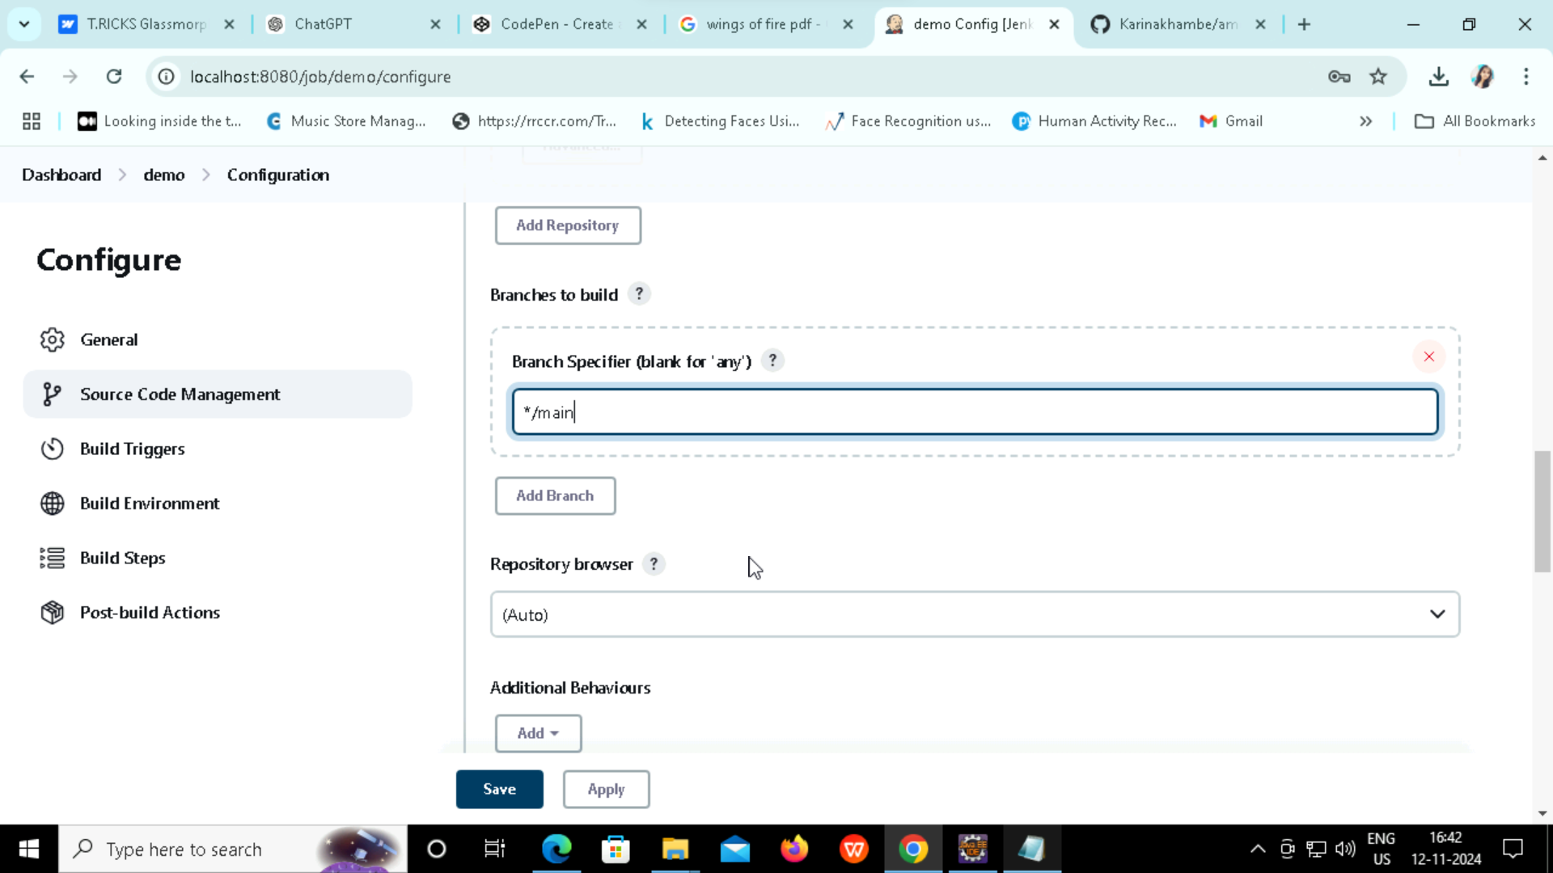

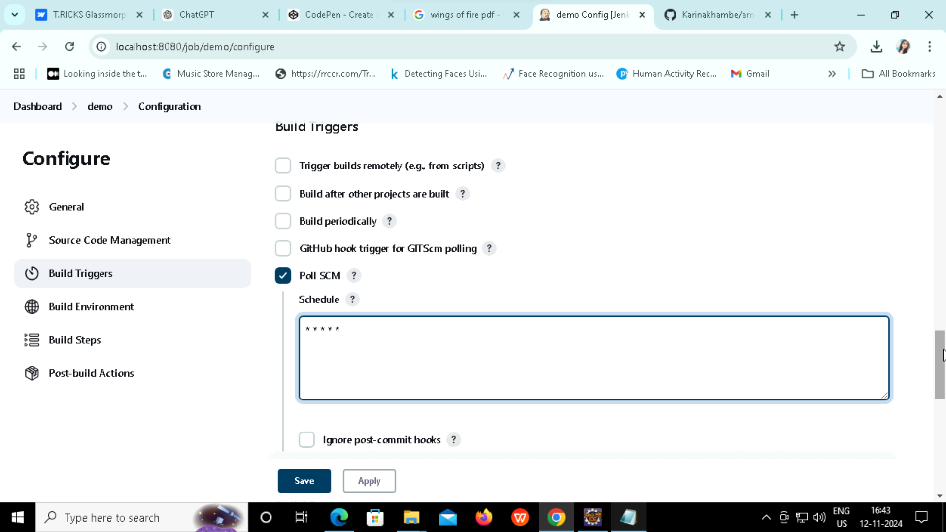

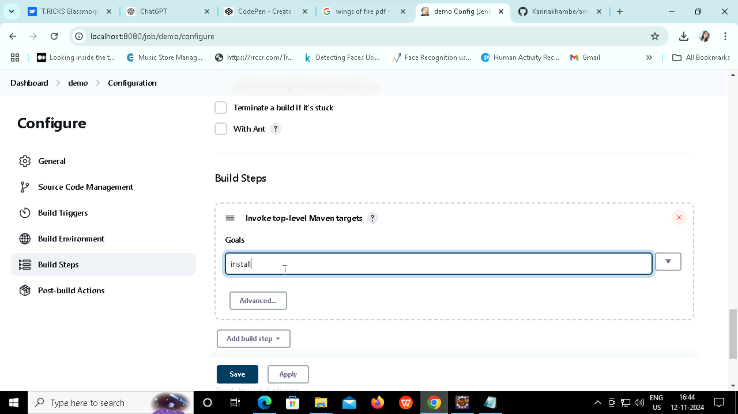

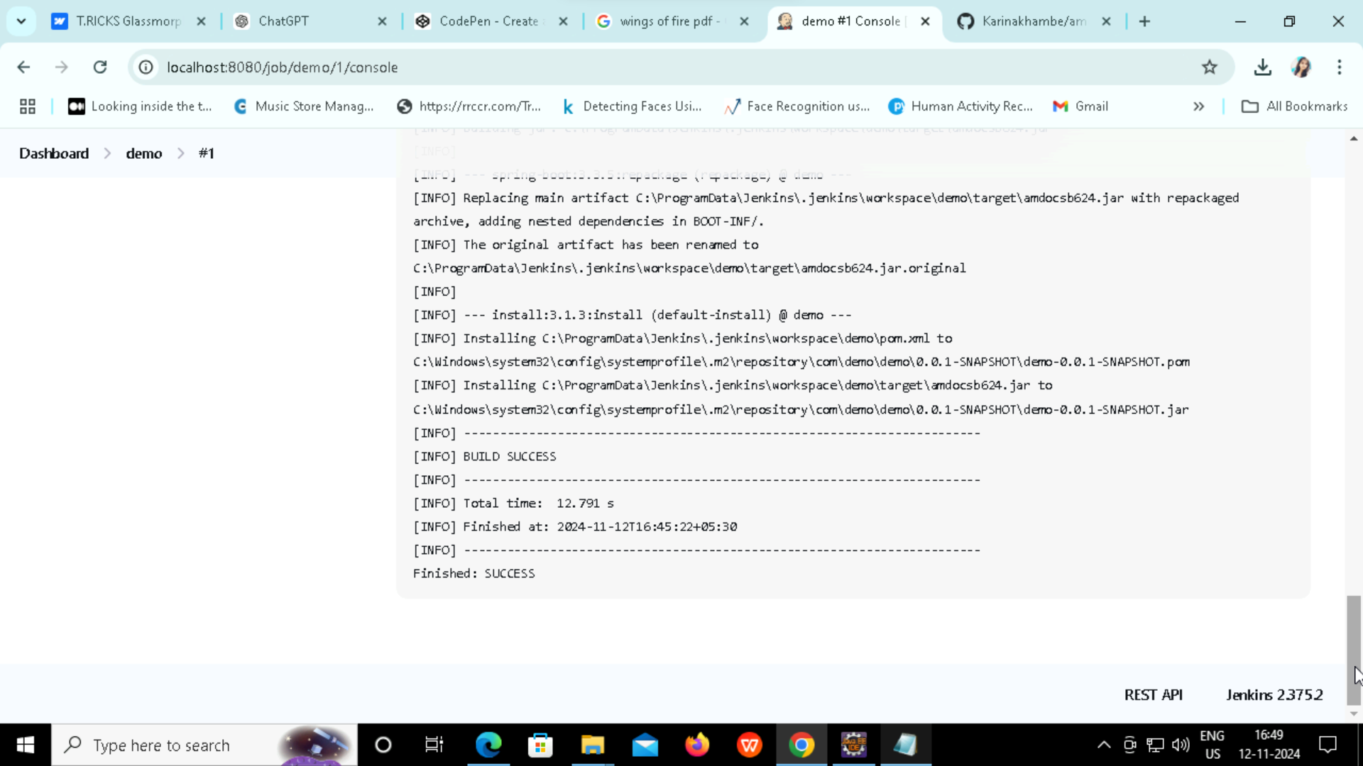

**How to Create a Tag and Docker Repository**

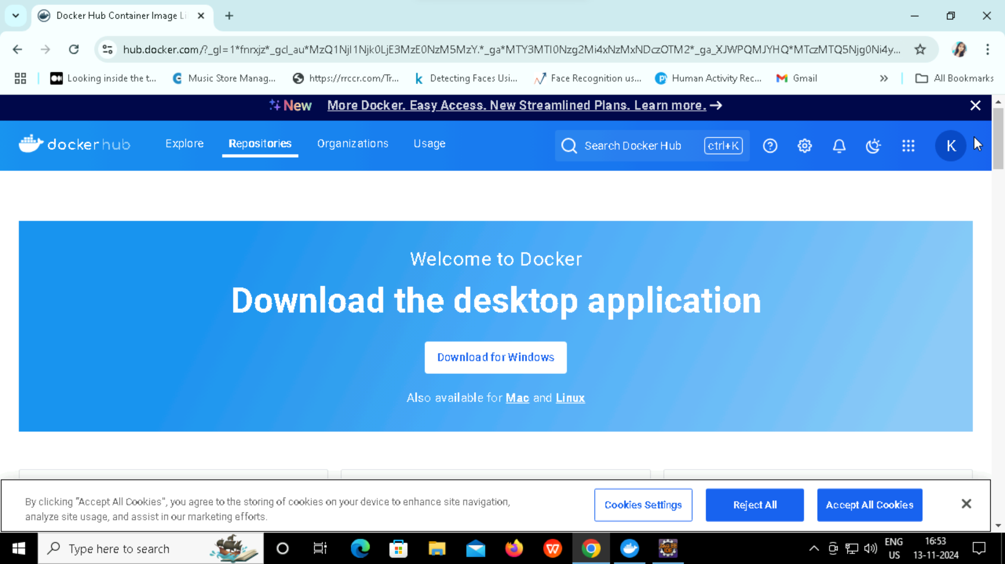

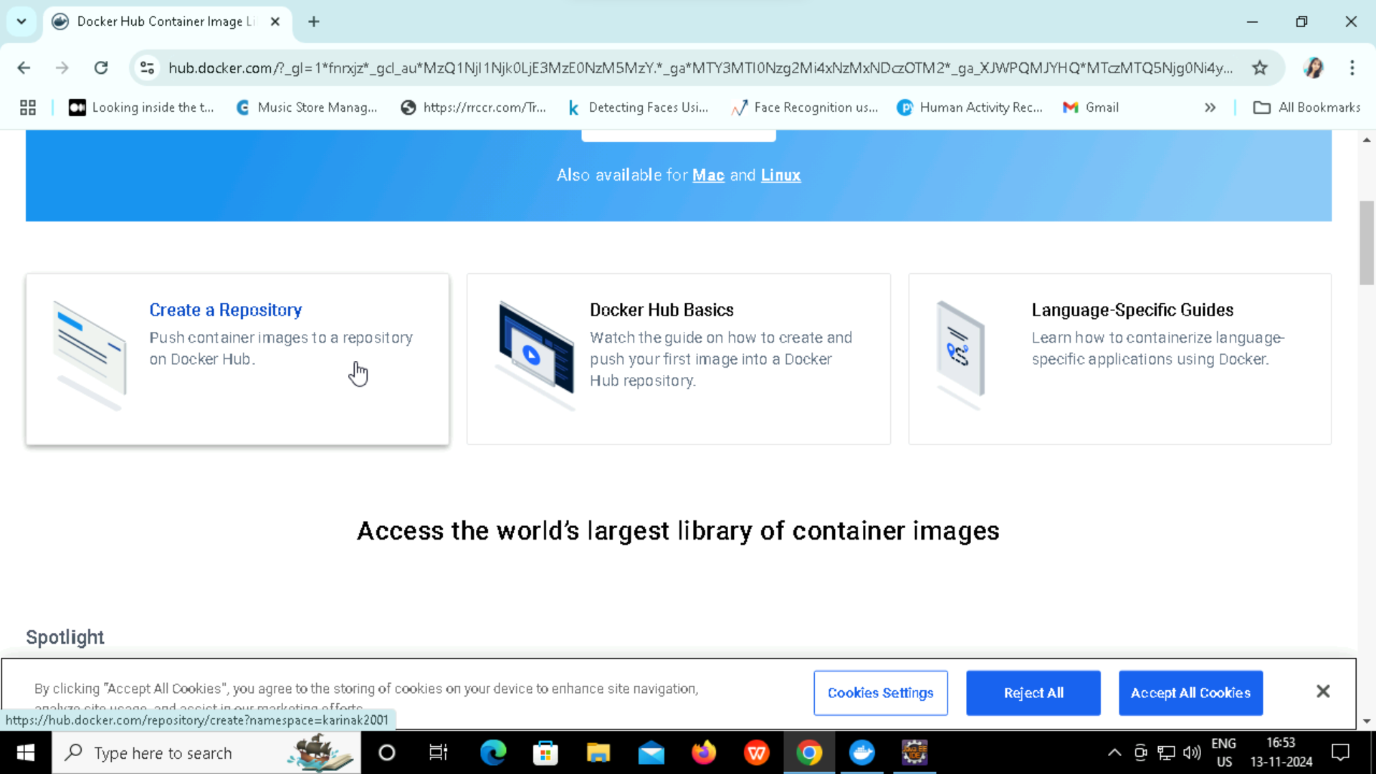

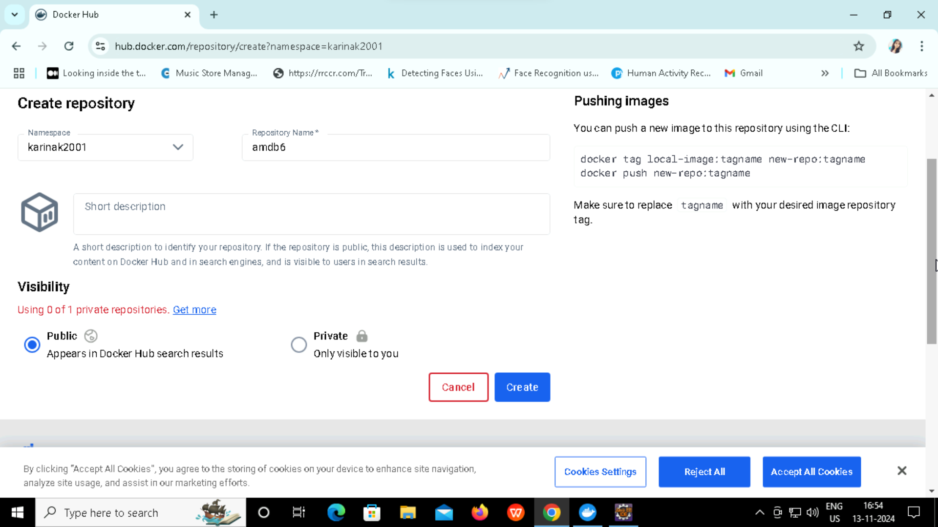

**Create a Tag inside a normal command prompt**

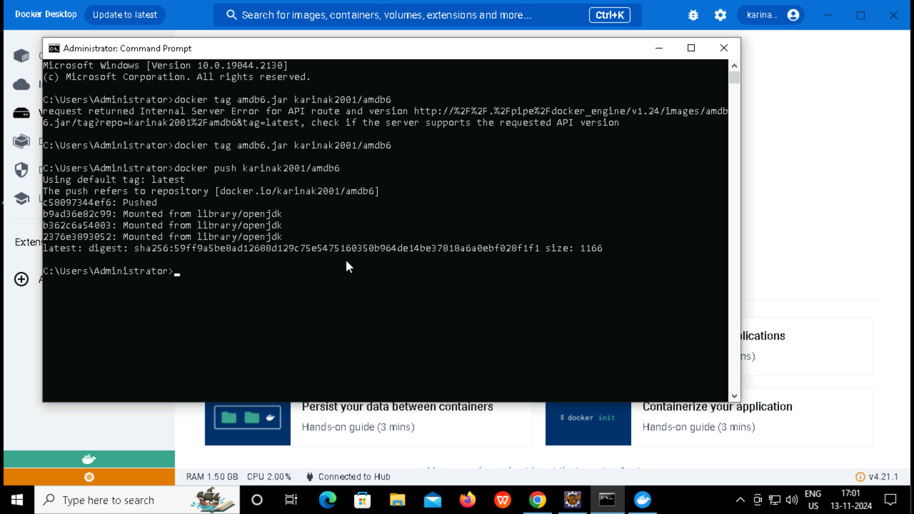

**After creating a tag check it on docker hub -> Repository -> Tags**

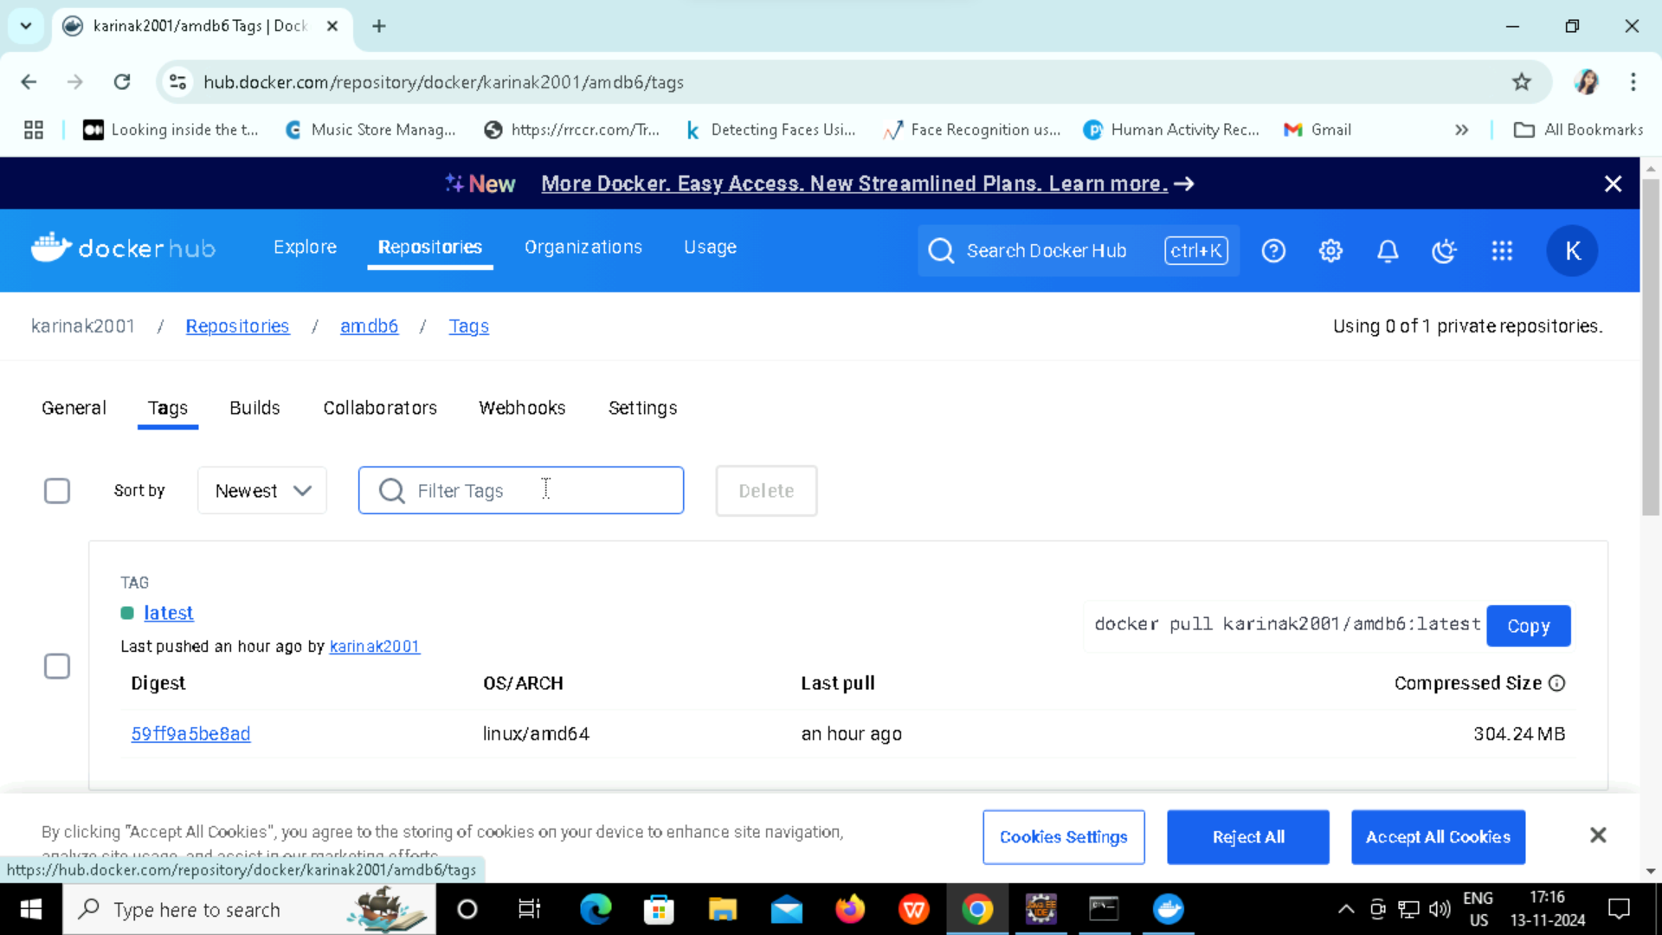

click on deployment

click on install

Path : Folder path paste

enter

sample war file

select war file

click on next

install this deployment as an application

next

change name if u want

next

yes, take me to deployment screen